CI587 – Report, Finley Nye, FN170
Student Declaration
I declare that my use of Generative AI tools is permitted under the assignment’s RAG rating (amber or green). Where appropriate I have checked the accuracy and bias of any outputs generated by Generative AI tools. By submitting this assignment, I acknowledge that I am responsible for any work presented.
I acknowledge use of Generative AI tools in the following areas:
Area where generative AI has been used  See example activities in each area on BSSH website | What tool did you use and what did you use it for? Include prompts if required by your assessment brief  Example: Preparation – Used Copilot to get ideas of suitable report structures. Prompt : “I am a third year undergraduate student in the UK, suggest a suitable outline structure for a research project report”
Assessment planning  e.g. time management | ChatGPT was used to help interpret the assignment brief and break the task in to manageable sections.  Example Prompt “Explain what each section of the CI5187 template requires”.
Preparation  e.g. explaining terminology, exploring background | ChatGPT used to clarify terminology relating to Phaser 3 concepts (scene, lifecycle, physics bodies, timed events) and to explain relevant game dev concepts already taught in the module.  No external research sources were generated.  Prompt example “Explain Phasers scene lifecycle in simple terms.”
Research, note taking and organising ideas  Eg initial research, explaining source material | ChatGPT assisted in summarising the design intentions and helped organise the notes when planning parts of the report.  No external sources were produced; all references in the report were researched and manually added by me.
Writing  e.g. drafting, transforming content | ChatGPT supported the drafting and refinement of certain descriptive sections ( explaining object behaviours, mechanic summaries) All final wording was rewritten or adopted by me.
Editing and revision  Eg feedback on structure | ChatGPT was used to provide feedback on structure and coherence of my report sections.  Example prompt “Review this paragraph and suggest clearer academic wording”.
Proofreading  e.g. correct spelling and grammar | ChatGPT was used for grammar and clarity improvements in early drafts.
Calculations, data handling and coding  e.g. analysis of data | ChatGPT assisted ONLY with explaining Phaser behaviours and helping to plan solutions (such as scene transitions, or object orientated structuring). All code used in Fuel Field was written implemented and tested by me.
Creation of visuals  e.g. image generation | No AI image generation used. All Diagrams (annotated screenshots) were created by me in PowerPoint.
Other  Anything that does not fit in the areas above | No additional generative AI uses beyond states areas.

CI587 – Report, Finley Nye, FN170 1
Game Summary: 2
Core Loop: 2
Rules: 2
Story board: 3
Score / Level map: 4
Implementation Specification: 5
Player Object: 5
Projectile Spawning: 7
Asteroids Spawning: 9
Fuel System: 11
Hearts / Health System: 13
Score System: 13
Scene and Code Structure: 13
Collision Manager: 13
Pickup Manager: 13
Comet Warning Manager and Idle Timer: 13
Helper Utilities: 13
Upgrade System: 13
Spawner System: 13
Assets: 13
Research: 13
Implementation Evaluation: 13
Appendix: 13
Debugging: 13
Fuel: 13
Upgrades: 13
Collision: 13
Spawner: 13
Code Snippets: 13
FN_Ship: 13
FN_Gun: 13
Gameplay Recording: 13
References: 13

Game Summary:
Fuel Field is a browser based arcade shooter developed in Phaser 3, the project began as a simple Asteroids style movement prototype, but through iterative development it grew into a modernised space shooter with fuel based mechanics, responsive feedback systems and an emphasis on clarity and immersive game feel.
The core design goal was to reinterpret a classic arcade format using Morden web technologies whilst keeping the JavaScript architecture clean, readable, and easy to follow. This also meant the project had to focus on:
- Clear Player feedback (health system, damage flash, red damage vignette, synth warning tone).
- Responsive Controls (intertia based movement, stagger, knock back, dynamic fire rate)
- Readable UI and Visual Clarity (pixel art, star field sprite sheet layers, simple colour coded danger cues)
- Scalable Systems (modular managers for scoring, HP, spawning, collisions)
During development, it became clear that while the core loop (movement, shoot and collect) was fun, it risked becoming predictable in longer sessions. A small upgrade layer was added to give players more variety and slight replayability without expanding the intended scope drastically.
These upgrades do not transform the game into a full rogue like, things like weapon adjustments, small stat boosts were all added to accommodate.
Across the project these improvements were informed by shot weekly play tests and iterative development, research into classical arcade shooters and modern “survivor like” game design patterns. Fuel Field aims to blend a mixture of early arcade games with the readability and clarity of modern indie shooters.

Core Loop:
- Move around using WASD keys.
- Shoot asteroids to gain score.
- Collect fuel to avoid running out.
- When fuel = 0, the player transitions to Game Over Scene and can restart immediately.

Rules:
- Player loses fuel gradually over time.
- Colliding with asteroids decreases fuel faster.
- Colliding with asteroids decreases hearts (4 hearts total).
- Collecting fuel pods refills the tank.

Story board:

TITLE SCREEN LAYOUT, Displays title, background starts and looping background audio.
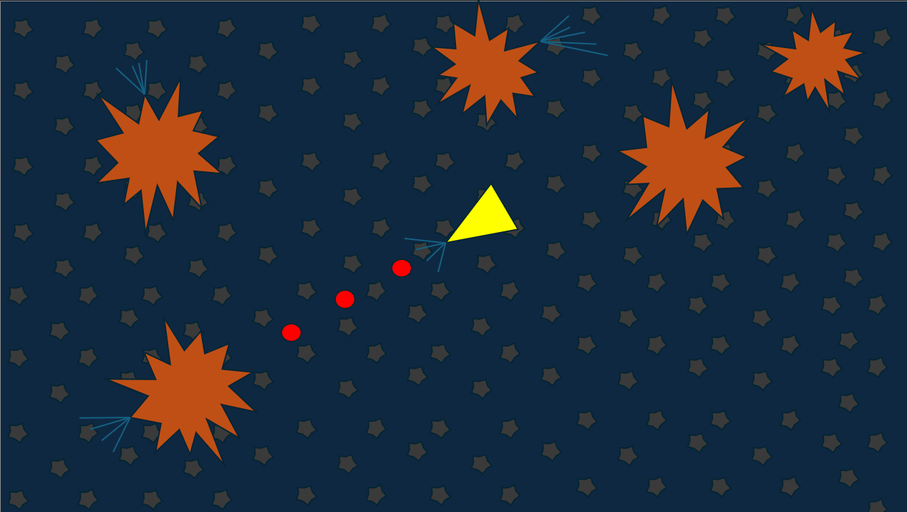
PLAYER SHOOTING ASTEROIDS.
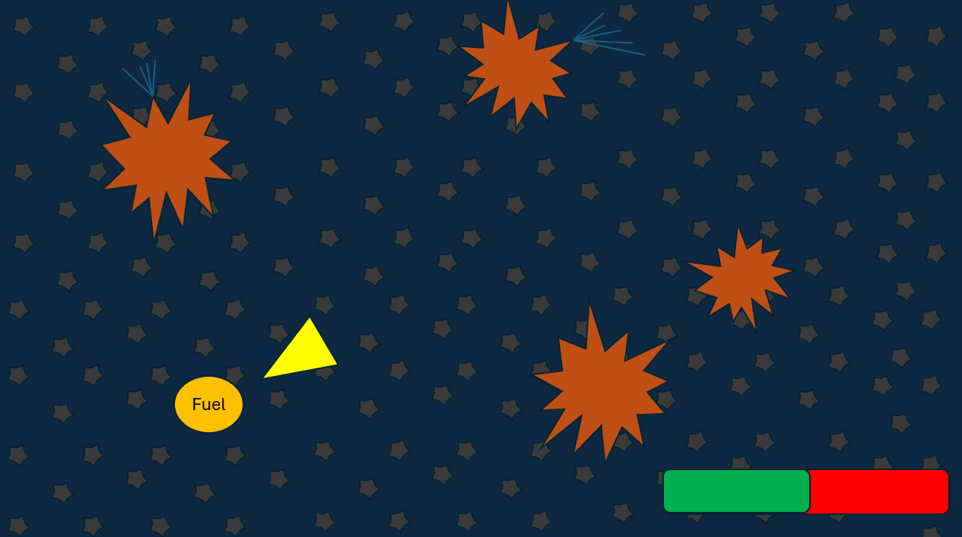
PLAYER PICKING UP FUEL .
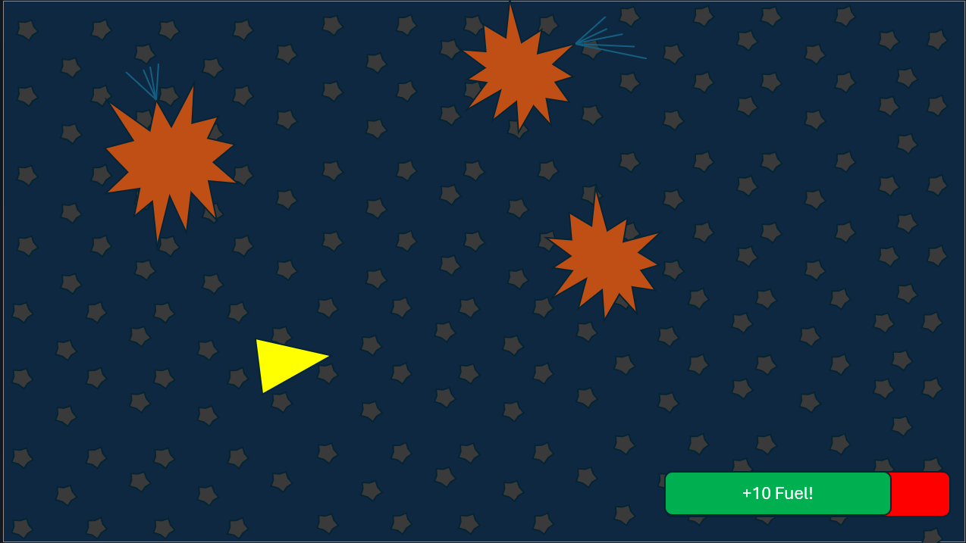
PLAYERS FUEL INCREASING.

GAME OVER SCREEN LAYOUT. Displays Game Over Text, background stars and looping background audio.

Score / Level map:
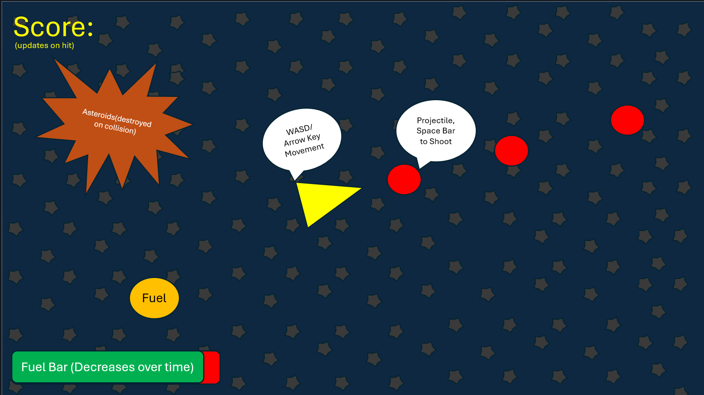
ANNOTATED SCREENSHOT OF GAMEPLAY FUNCTIONS AND GAMEPLAY OBJECTS MOCKED UP IN POWERPOINT.
This is an annotated gameplay layout that illustrates the main elements of Fuel Field. The player (yellow triangle) moves using WASD / Arrow keys and fires projectiles using the space bar. Those same projectiles when colliding with the asteroids drop fuel (yellow circles), which the player can pick up and increase their fuel. The fuel bar is shown in the bottom left and it slowly depletes over time. When it reaches zero, the game ends.

Implementation Specification:

Player Object:
The player ship is implemented as a dedicated class “FN_Ship” its responsible for handling all movement, input handling and core survival behaviours. Movement takes influence from Asteroids, using intertia based control and a capped velocity to keep motion readable and responsive. The ship applies thrust in the direction it is currently facing, with drag used to gradually slow down any unwanted momentum.
SCREENSHOT OF PLAYER SHIP IN GAME SHOWING MOVEMENT DIRECTION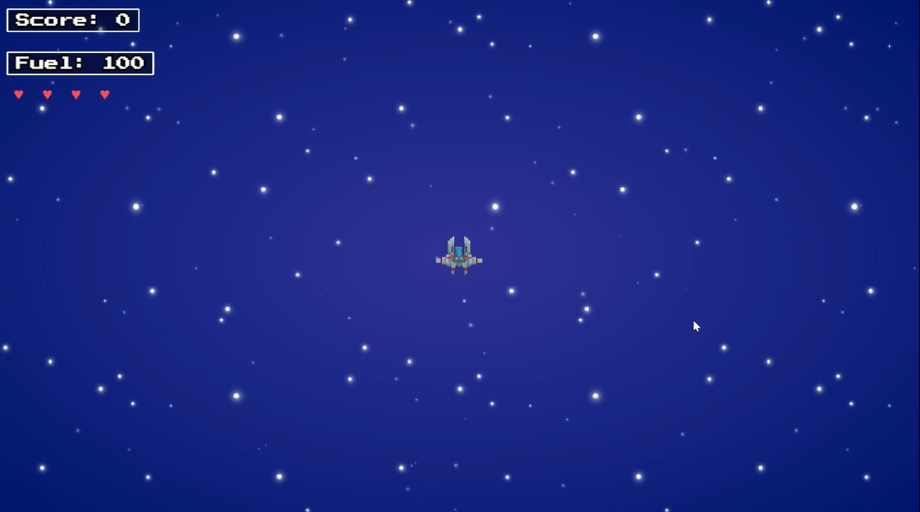
Boosting adds an additional layer of decision making. When held, it increases the thrust power of the ship but at the cost of faster fuel consumption, reinforcing fuel as a central resource
BOOST FUEL DRAIN WITH UI VISIBLE
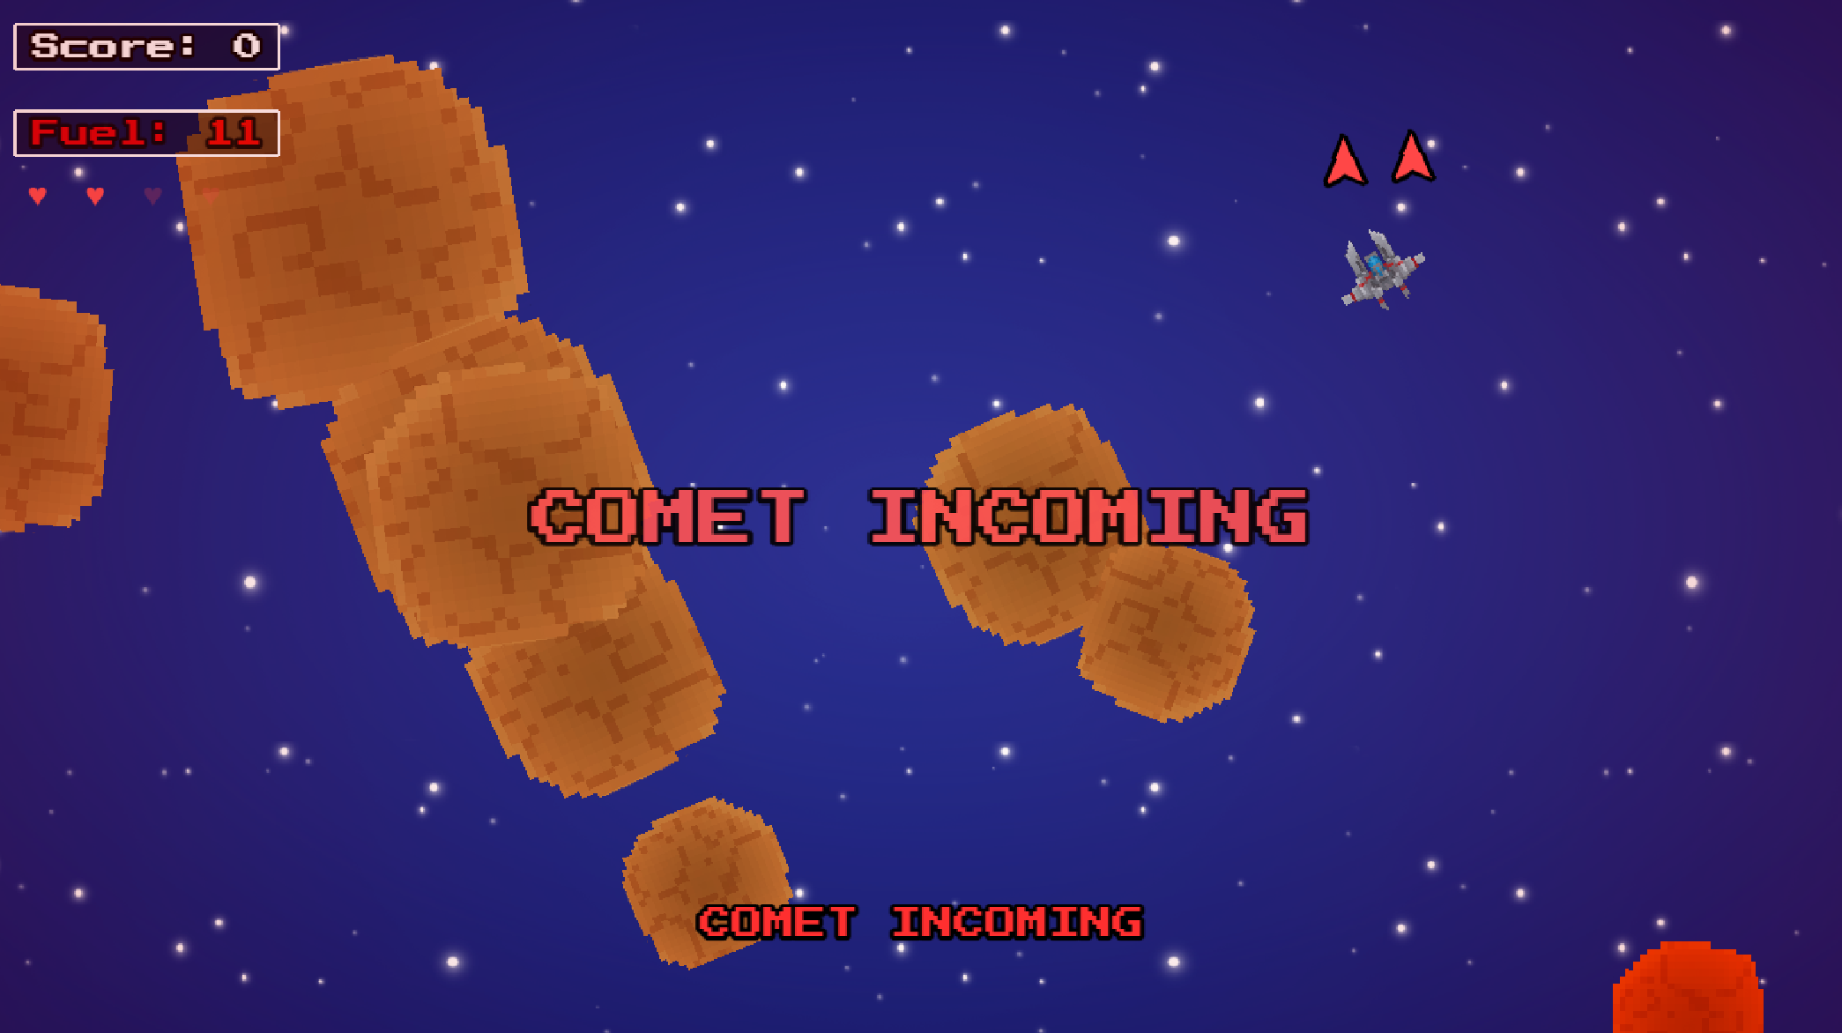
Damage introduces short disruptions to player control. When hit, the ship receives knock back and becomes briefly invulnerable, this is communicated through a simple blinking effect. This prevents repeated hits in quick succession and encourages repositioning.
SHIP FLASHING RED SCREENSHOT
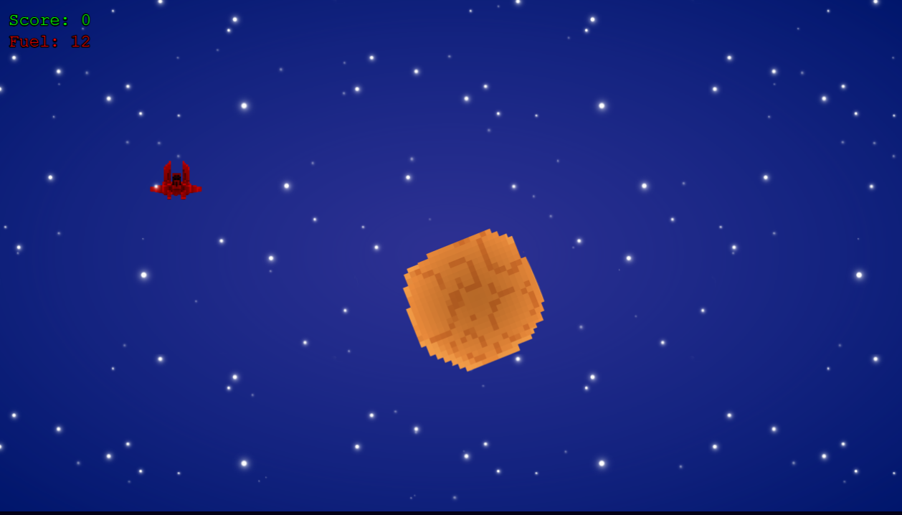
Fuel acts as a long term limiter. Standard movement does not consume fuel, but boosting does, and the value is clamped between set bounds. Reaching zero triggers the ships destruction and transitions to the Game Over state.
FUEL UI DURING NORMAL VS LOW FUEL SCREENSHOT
An idle timer monitors the ships movement speed, if the player remains still for too long, a comet attack is triggered. This was added to discourage passive play and maintain pacing and prevent scenarios where the player can remain safe without engaging with the games core systems.
COMET WARNING TRIGGER FOR IDLE TIMER
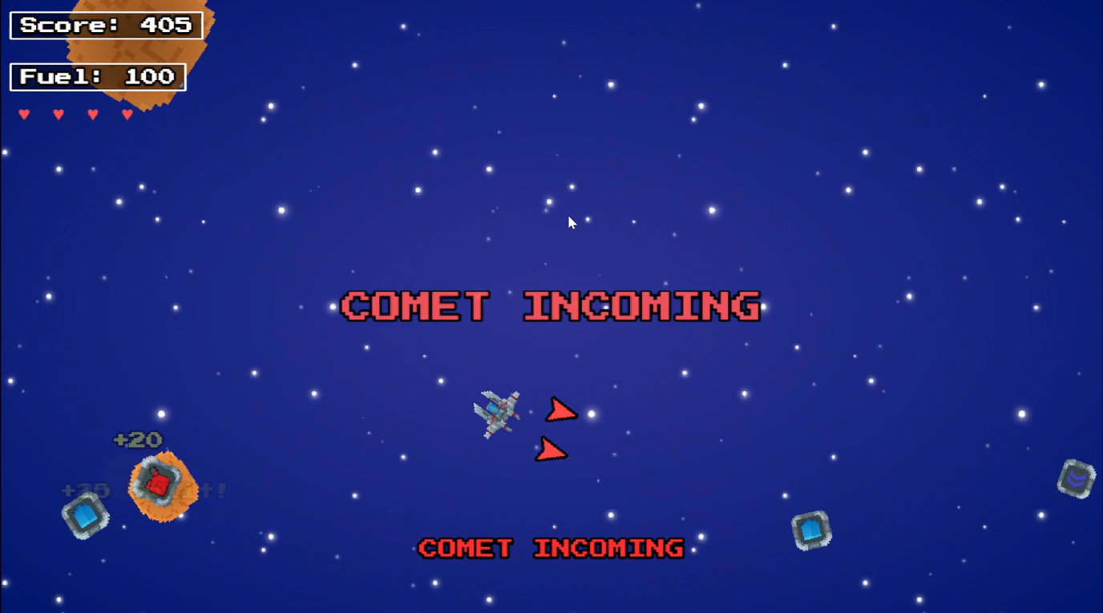
Overall, the player object maintains a balance between control, risk and resource management, which helps keep moment to moment gameplay active and deliberate.

Projectile Spawning:
Projectile spawning is handled through a dedicated “FN_Gun” class which manages firing logic, cooldown timing and weapon pattern upgrades. When the fire input is held. The gun checks an internal cooldown to ensure bullets cannot be fired faster than the intended rate. This keeps pacing controlled and allows fire rate to scale with upgrades and scale with the difficulty appropriately.
SINGLE BASIC PROJECTILE FIRING SCREENSHOT

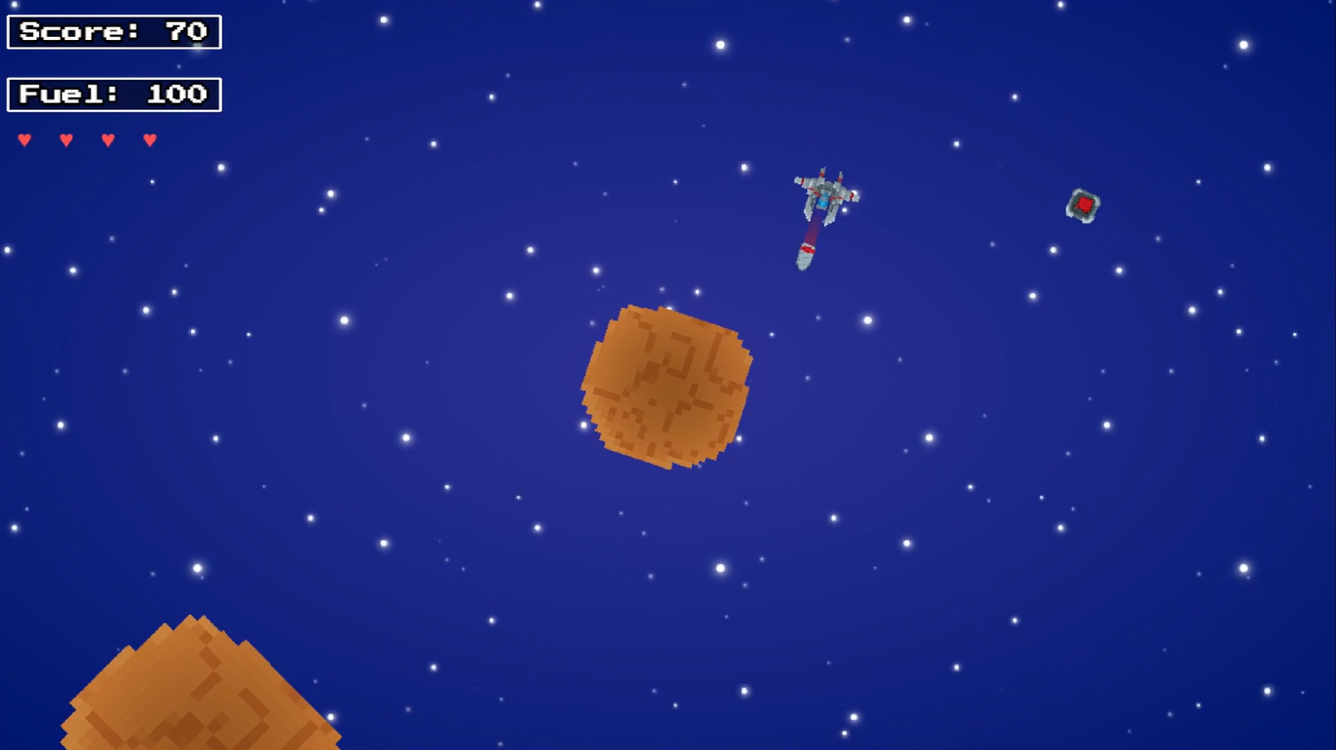Projectiles are instantiated at the ships nose and travel in the direction of its current rotation, maintaining consistent behaviour with arcade shooters. Each bullet uses a fixed collision radius and is automatically destroyed after a short duration to prevent unnecessary scene build up.
As upgrades were introduced, additional firing patterns became available. These include:
- Twin Shot: fires two parallel projectiles which are offset from the ships centre

- Spread Shot: fires multiple bullets in a cone pattern, which allows for broader coverage

- Auto Fire: removes the need for repeated key presses, allowing continuous fire while the input is held

These patterns are created through small adjustments to spawn positions or angles, allowing variety without changing the underlying projectile class.
SPREAD SHOT UPGRADE DEMONSTRATION SCREENSHOT
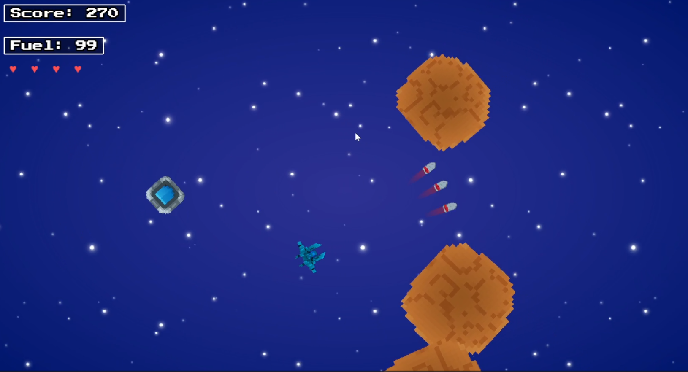TWIN AND AUTO FIRE SCREENSHOTS
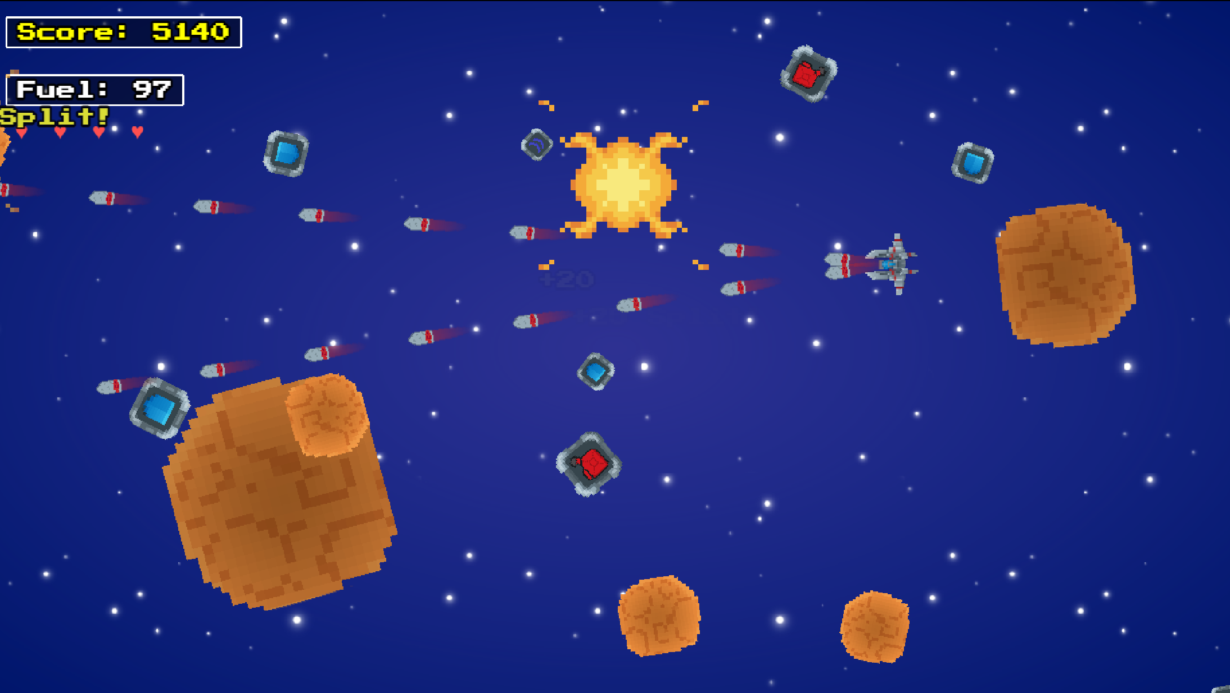Each upgrade stacks with fire rate modifiers, creating noticeable shifts in combat tempo while keeping the system modular and easy to maintain.

Asteroids Spawning:
Asteroids form as the primary threat in the game and are implemented using a dedicated “FN_Asteroids” class. They spawn at random points along the screen edge and are directed toward the centre of the play area to maintain predictable entry paths. Randomised rotation and movement speed add variation without compromising readability. Difficulty increases over time as the spawner raises speed values and shortens the intervals, continually adding pressure during longer runs.
LARGE, MEDIUM, SMALL ASTEROIDS SCREENSHOT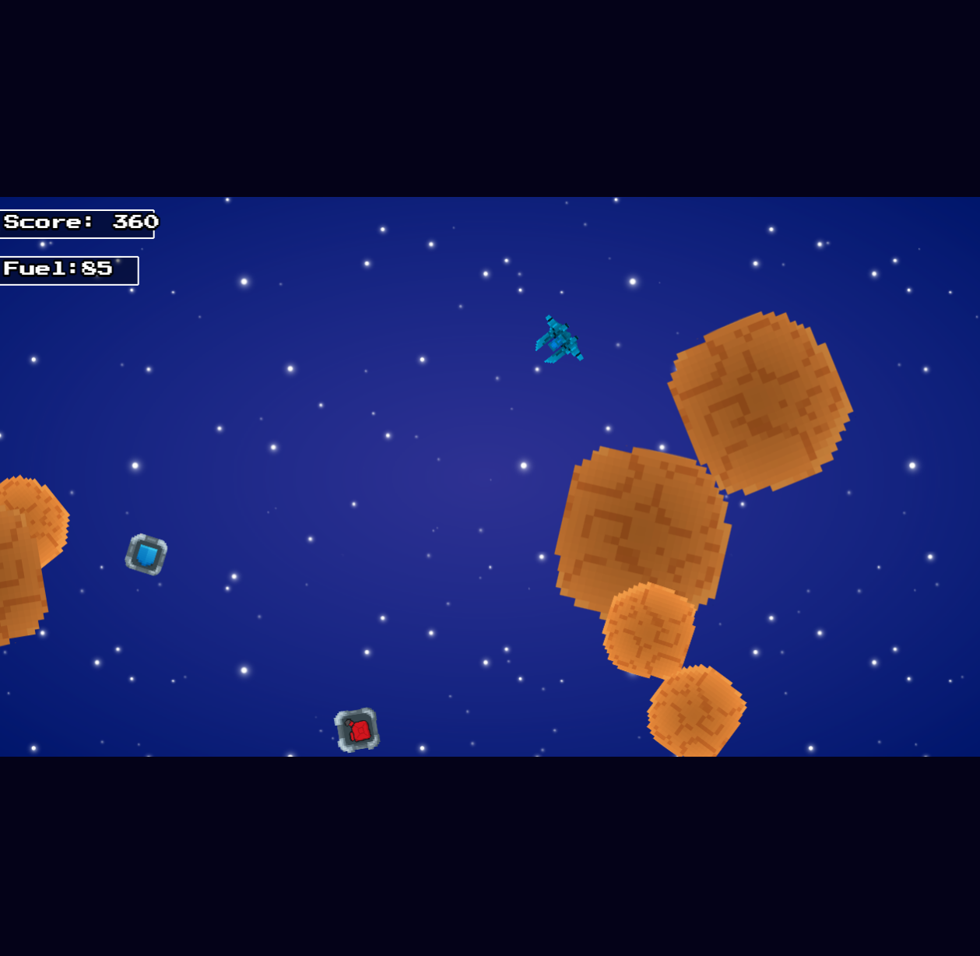
Asteroids update manually each frame rather than using Arcade Physics. This avoids tunnelling issues at higher speeds and ensures consistent collision behaviour for bullets and the player. When the upgrade menu is opened, asteroid movement pauses to prevent unfair damage during selection.
Destroying an asteroid triggers scoring, floating text feedback and a chance to drop pickups such as; fuel, speed boosts or shield. Drops are intentionally infrequent until later in the run to support the reward loop.
SCORE SYSTEM SCREENSHOT (+20, +15)
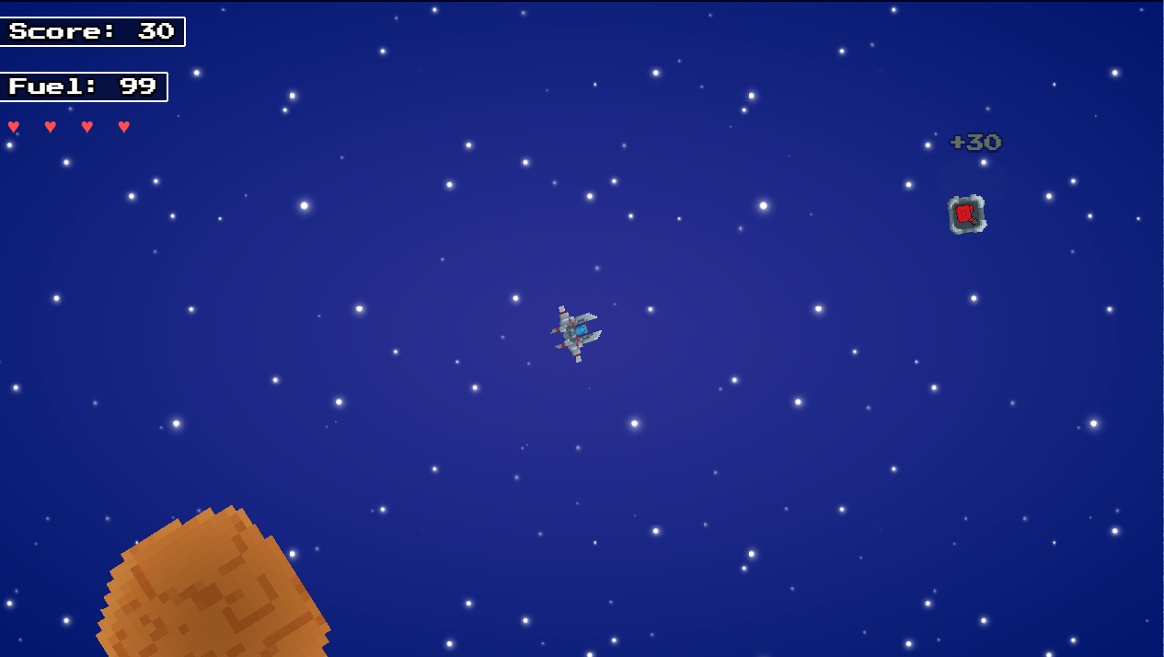Larger asteroids can split into smaller fragments on destruction. These fragments inherit reduced scale and adjust velocities, creating short bursts of intensified challenge that mirrors classic arcade design.
SPLITTING BEHAVIOUR FOR THE ASTEROIDS SCREENSHOT
Overall, the asteroid system balances controlled randomness with scalable difficulty, ensuring threats remain readable, varied and appropriately challenging throughout the run.

Fuel System:
Fuel functions as one of the games core resources and directly shapes the players ability to boost effectively. The player begins with a fixed maximum fuel value, and only boosting consumes it, preserving accessibility during standard movement. Fuel is clamped within valid bounds to prevent exceeding the maximum value after picking up a shield or a speed boost pickup.
SCREENSHOT SHOWING CURRENT FUEL LEVEL
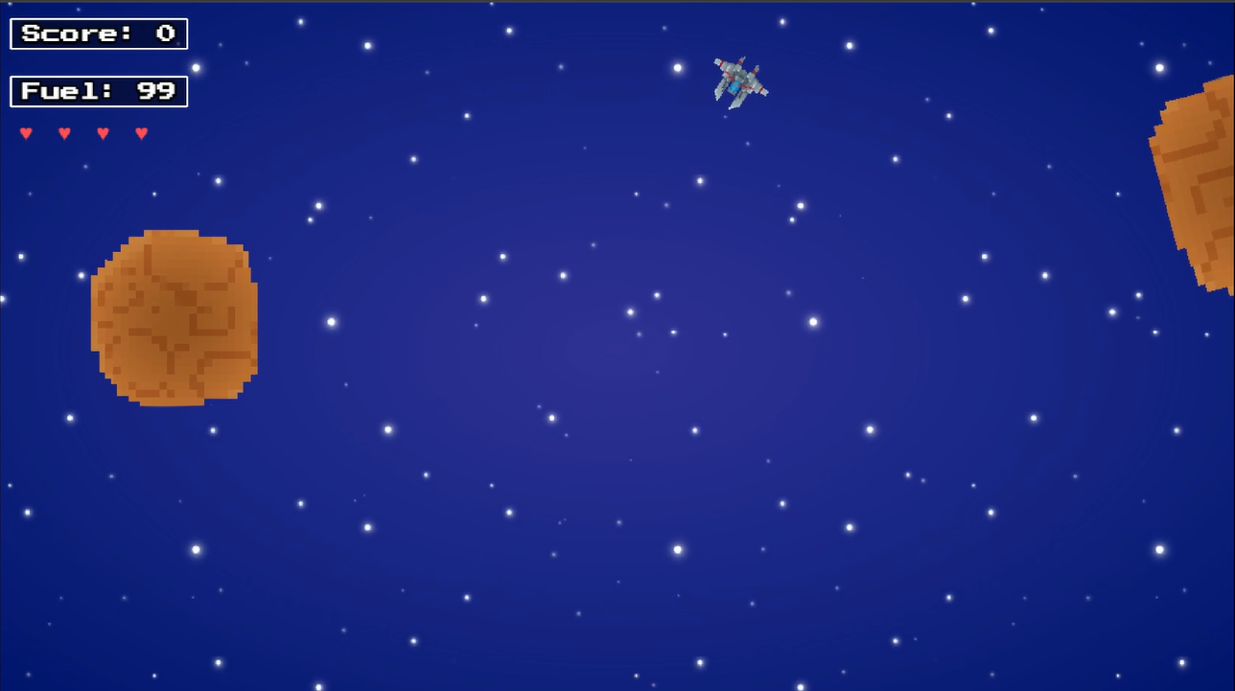
Fuel drain scales with difficulty, making aggressive movement more costly as the run progresses. Reaching zero fuel immediately triggers the ships destruction and transitions to the Game Over state, reinforcing fuel as a long term survival constraint.
SCREENSHOT SHOWING BOOST FUEL DRAIN
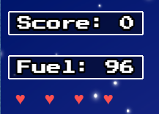
Fuel pickups provide recovery and form a key part of the reward loop. When they are collected, they restore a small, randomised amount of fuel, and trigger clear feedback through a green tint, floating text, audio cues and a slight velocity bump. These responses ensure that pickups remain readable even in busy scenes.
FUEL PICKUP RESTORATION MOMENT SCREENSHOT
The fuel system also interacts with upgrades, which can increase maximum fuel or improve regeneration, supporting more boost heavy playstyles. In addition, fuel ties into the idle timer system, encouraging constant movement and preventing overly defensive strategies.
FUEL AT ZERO LEADING TO SHIP DEATH SCREENSHOT
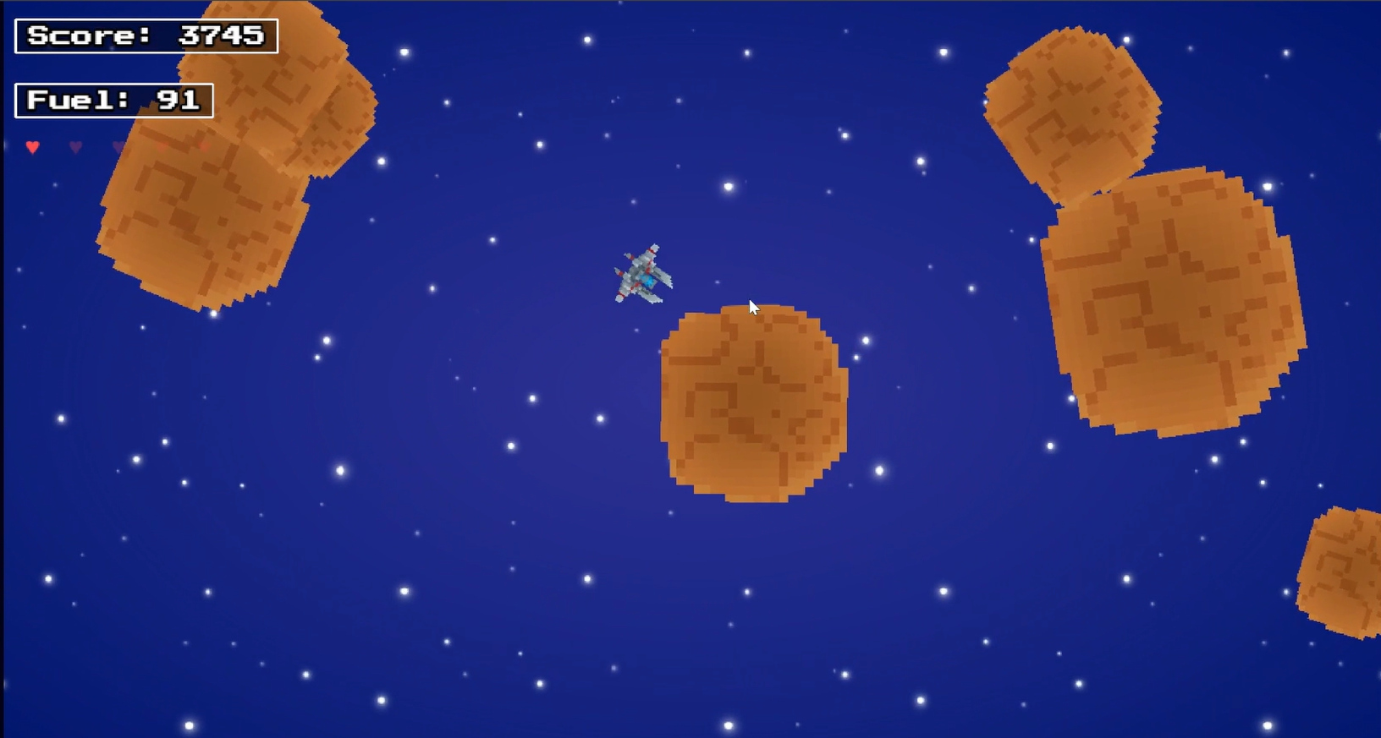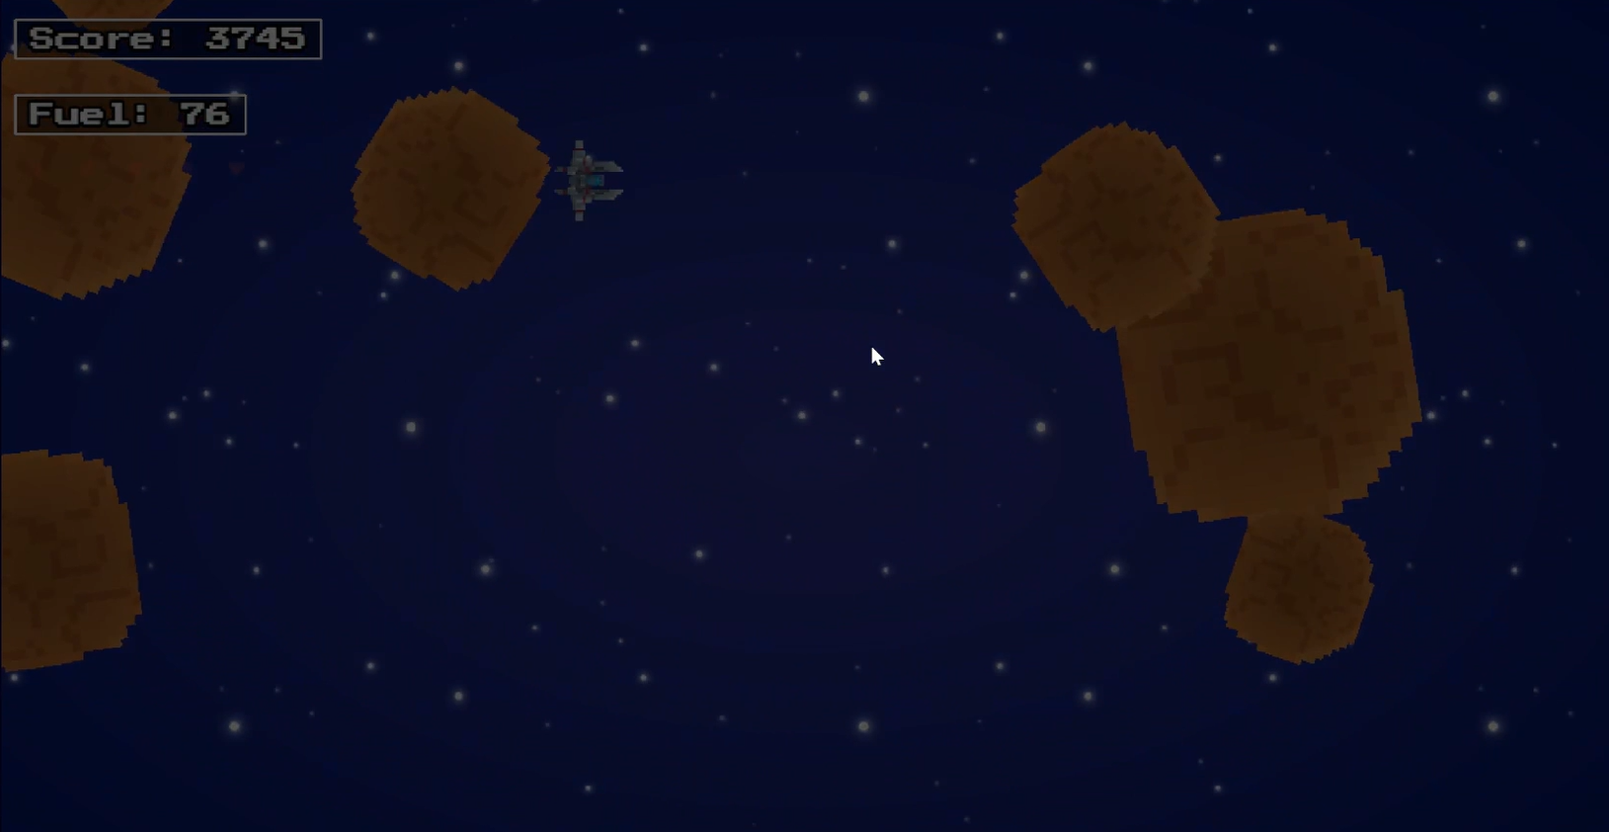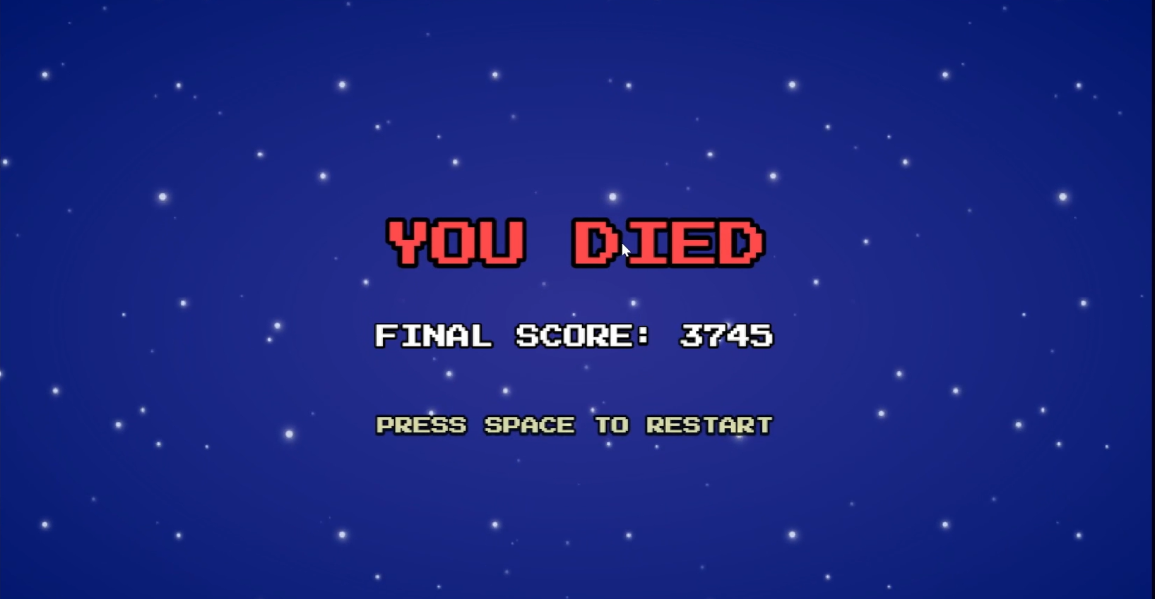
Overall, the fuel system reinforces pacing, resource management and movement driven decision making throughout the run.

Hearts / Health System:
The health system is represented through a heart based UI and is managed by a dedicated class “FN_HPManager” that syncs the ships internal health values. The player begins with a fixed number of hearts (4), and each hearts represents one point of health. This provides a clear and readable indication of survivability and reinforces the games retro-inspired presentation.
HEART UI SCREENSHOT WITH FULL HEALTH
Taking damage reduces eths ships health and triggers several interconnected feedback systems. When hit, the ship is temporarily invulnerable, preventing it from taking repeated damage in rapid succession. This invulnerability is communicated through a timed blinking effect that alternates the ships alpha levels. The blinking serves both mechanical purpose and visual clarity, helping to ensure the player can immediately recognise when the invulnerability window is active or not. In addition, the screen vignette briefly intensifies the, and a warning sound is played to reinforce the severity of the impact.
PLAYER BLINKING DURING IFRAMES SCREENSHOT
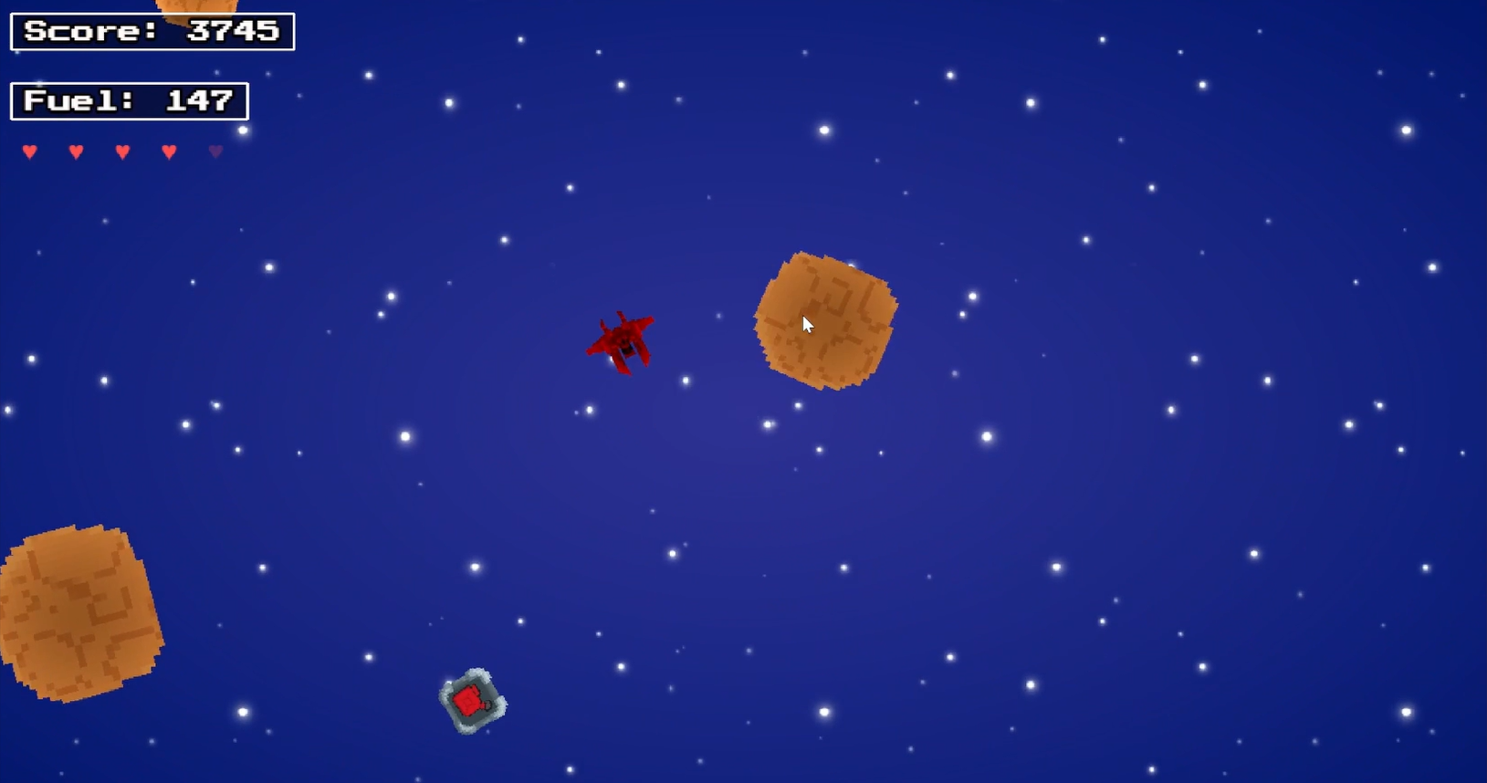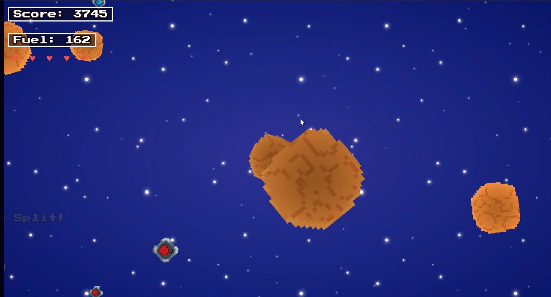
A knockback effect is applied on damage, which pushes the ship away from the source of collision, this prevents the player from remaining in a hazardous position, and encourages repositioning, and contributes to the overall feel of impact, a short stagger state also disables thrust and rotation, preventing the okayer from immediately cancelling out the consequences of a mistake. These systems collectively reinforce the deliberate movement and heighten the tension during high pressure gameplay scenarios.
KNOCKBACK / STAGGER SCREENSHOT
The health UI updates dynamically whenever health changes. If the player gains maximum health through the upgrade system, the heart manager adds additional heart icons and aligns them with the existing UI layout. Similarly, regeneration upgrades modify the internal cooldowns to allow periodic healing over time, by default. This allows for flexibility and integrates cleanly with the upgrade architecture.

A shield pickup provides temporary protection and interacts directly with the health system, when active, the shield sets the ship to an invulnerable state, prevents health loss, and applies a distinct colour tint to the ship for the duration of the effect. Once the shield expires, normal vulnerability resumes, and the tint is cleared to maintain visual consistency.
SHEILD TINT AND PICKUP ACTIVE SCREENSHOT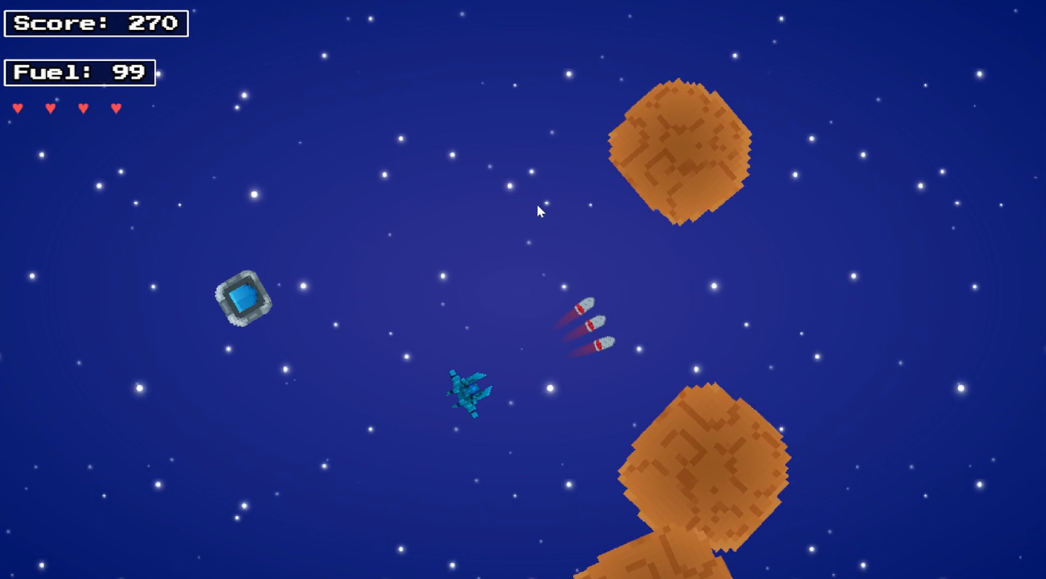
If the ships health does reach zero, the ship triggers its death sequence, which includes a tint shift, movement lock, and transition to the Game Over scene. This ensures that both the mechanical and visual feedback for reaching zero health remain consistent and readable.
ZERO HEALTH DEATH SEQUENCE SCREENSHOT
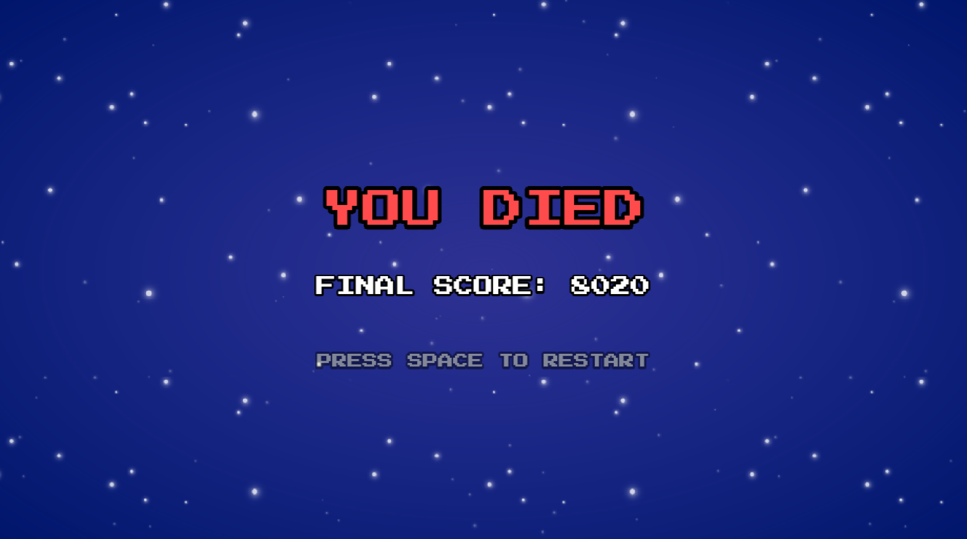
Overall, the health system combines clear UI feedback, responsive damage reactions, and layered protective mechanics. This supports the wider aim of maintaining difficulty balance while ensuring the player receives consistent feedback during the combat scenarios.

Score System:
The score system is managed through the “FN_ScoreManager”, which tracks and displays the players score throughout the run, Asteroids award points based on their size category, with larger asteroids giving higher rewards due to their increased presence and threat. Score values are stored within each asteroid object at spawn, ensuring consistency even if balance values change later. When an asteroid is destroyed, the score manager increments the total and spawns floating text at the impact point, giving the immediate visual feedback without disturbing the gameplay clarity.
SCORE UI SCREENSHOT TOP LEFT
Splitting behaviour extends this system by awarding the additional points when fragments are destroyed, reinforcing the challenge posed by larger asteroids. Floating text system communicates these rewards without cluttering the UI.
FLOATING TEXT UI SCREENSHOT ON ASTEROID DESTRUCTION
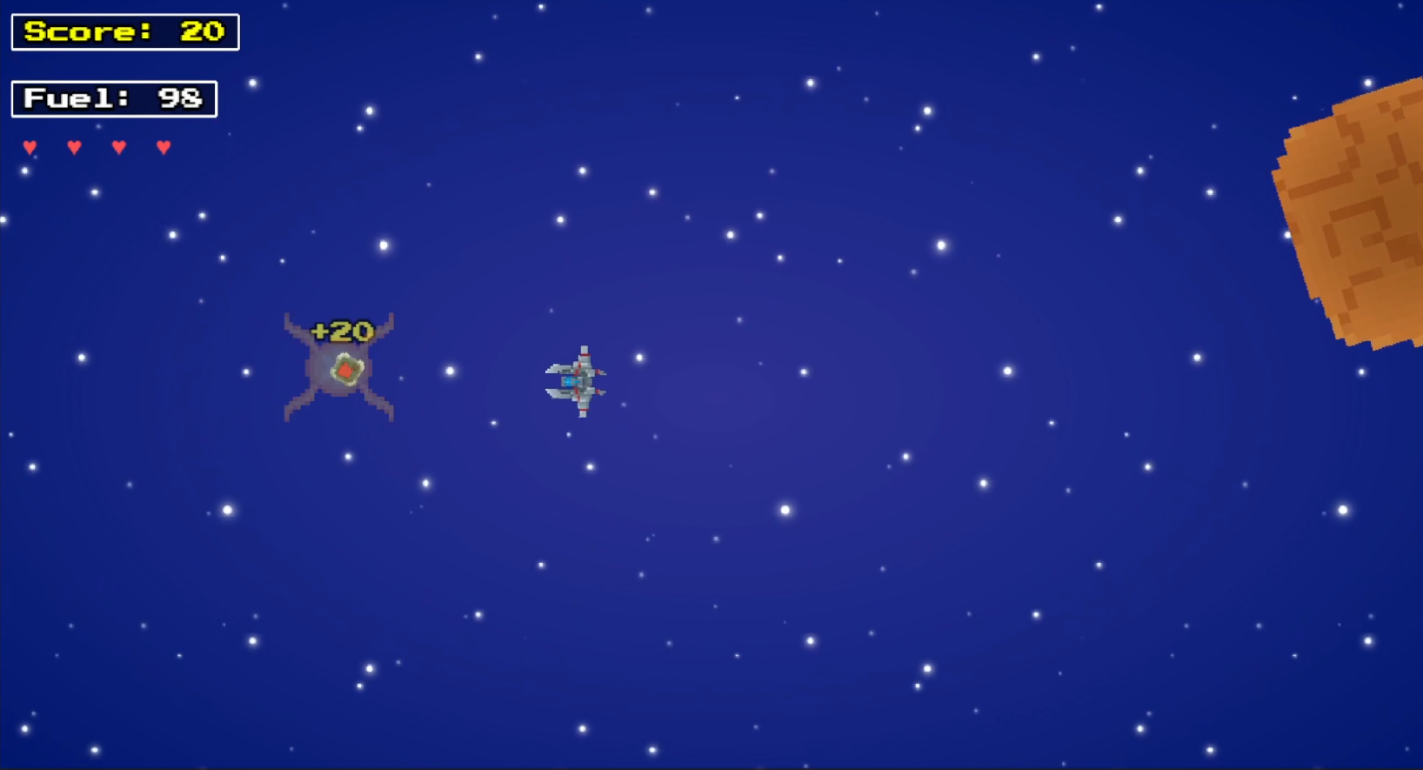
The score system also ties directly into the upgrade structure. Reaching specific score thresholds trigger the upgrade menu, pausing gameplay and giving the player three randomly rolled upgrades. This connects player performance to progression, ensuring longer and more successful runs naturally evolving through meaningful choices.
UPGRADE TRIGGER BASED ON SCORE THRESHOLD SCREENSHOT (200 THRESHOLD)
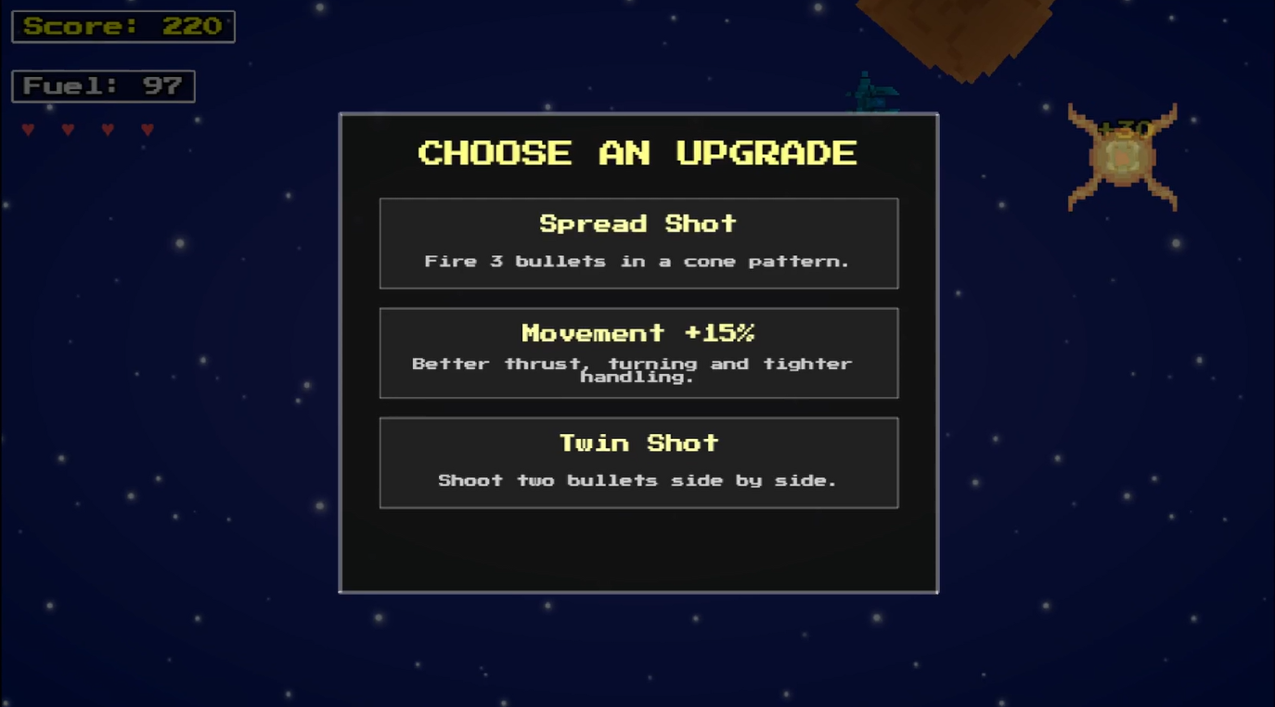
Overall, the score system reinforces the core loop of accuracy, momentum, and survival while maintaining constant readable feedback.

Scene and Code Structure:
Fuel Field is organised into multiple Phaser scenes and a set of modular managers, allowing gameplay logic to remain clear and maintainable. The main scenes include;
- StartScene.js – shows player title, looping background audio and prompts them to press space.
- MainScene.js - controls the entire gameplay loop (movement, spawning, scoring, UI, collision).
- GameOver.js - displays the final score and restarts the game on input.
Each handle only the behaviour relevant to its role. Title screen manages the introductory layout and audio, the Main Scene coordinates the gameplay systems, and the Game Over scene displays the final score and restart prompt.
SCENE FLOW SCREENSHOT
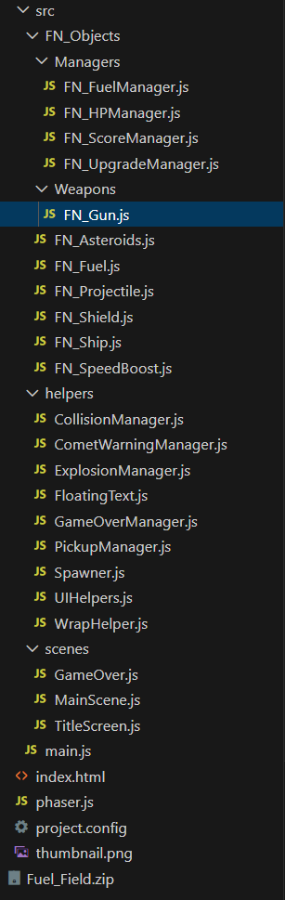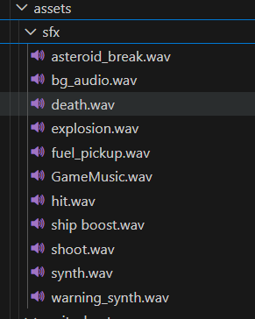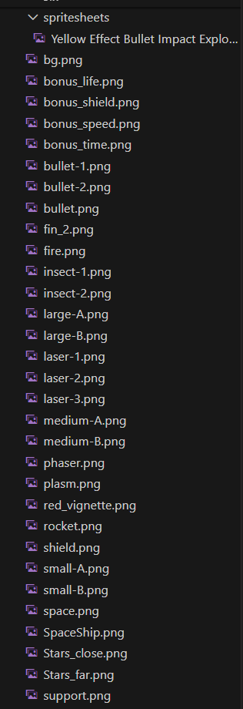
The Main Scene acts as the central point of coordination, it creates all core subsystem such as the player ship, asteroid spawner, collision manager, pickup manager, score manager, fuel manager and health manager. Each subsystem follows a single responsibility approach, keeping tasks like spawning, collision detection and UI updates isolated and easy to revise and iterate.
MAIN SCENE MANAGERS SCREENSHOT
Helper systems such as the “WrapHelper”, “UIHelpers”. “ExplosionManager” and “FloatingText” provide small, shared behaviours including screen wrapping, parallax handling, explosion effects and on screen feedback. Offloading these tasks keeps the Main Scene lightweight and improves overall project clarity.
The “CollisionManager” and “PickupManager” further centralise their respective logic, preventing the need for collision or pickup handling inside unrelated classes. Similarly, the “UpgradeManager” integrates cleanly by pausing gameplay when thresholds are reached and resuming once a selection is made.
This modular architecture makes the codebase easy to scale and ensures part of the project can be extended or debugged without affecting unrelated systems.
Overall, the scene and code structure emphasises clarity, modularity and long term maintainability. By distributing responsibilities across focused managers and helper classes, the final implementation remains scalable and easy to expand while supporting the core gameplay features.

Collision Manager:
Collision detection is handled through a dedicated “CollisionManager” class, which replaces Phaser’s built-in Arcade Physics overlap system with a fully manual approach. Phasers Arcade Physics does not perform continuous collision detection and can miss interactions when objects move at high speeds, a known “tunnelling” issue in the official documentation (Phaser, 2024).
https://docs.phaser.io/api-documentation/class/physics-arcade-arcadephysics
To ensure consistent behaviour, the Collision Manager performs per frame radial distance checks between objects. When the distance between two centres is less than the sum of their collision radii, the collision is processed immediately. This guarantees bullet to asteroid hits register reliably, even as projectile speed and difficulty increases.
MANUAL COLLISION HIT CHECK SCREENSHOT
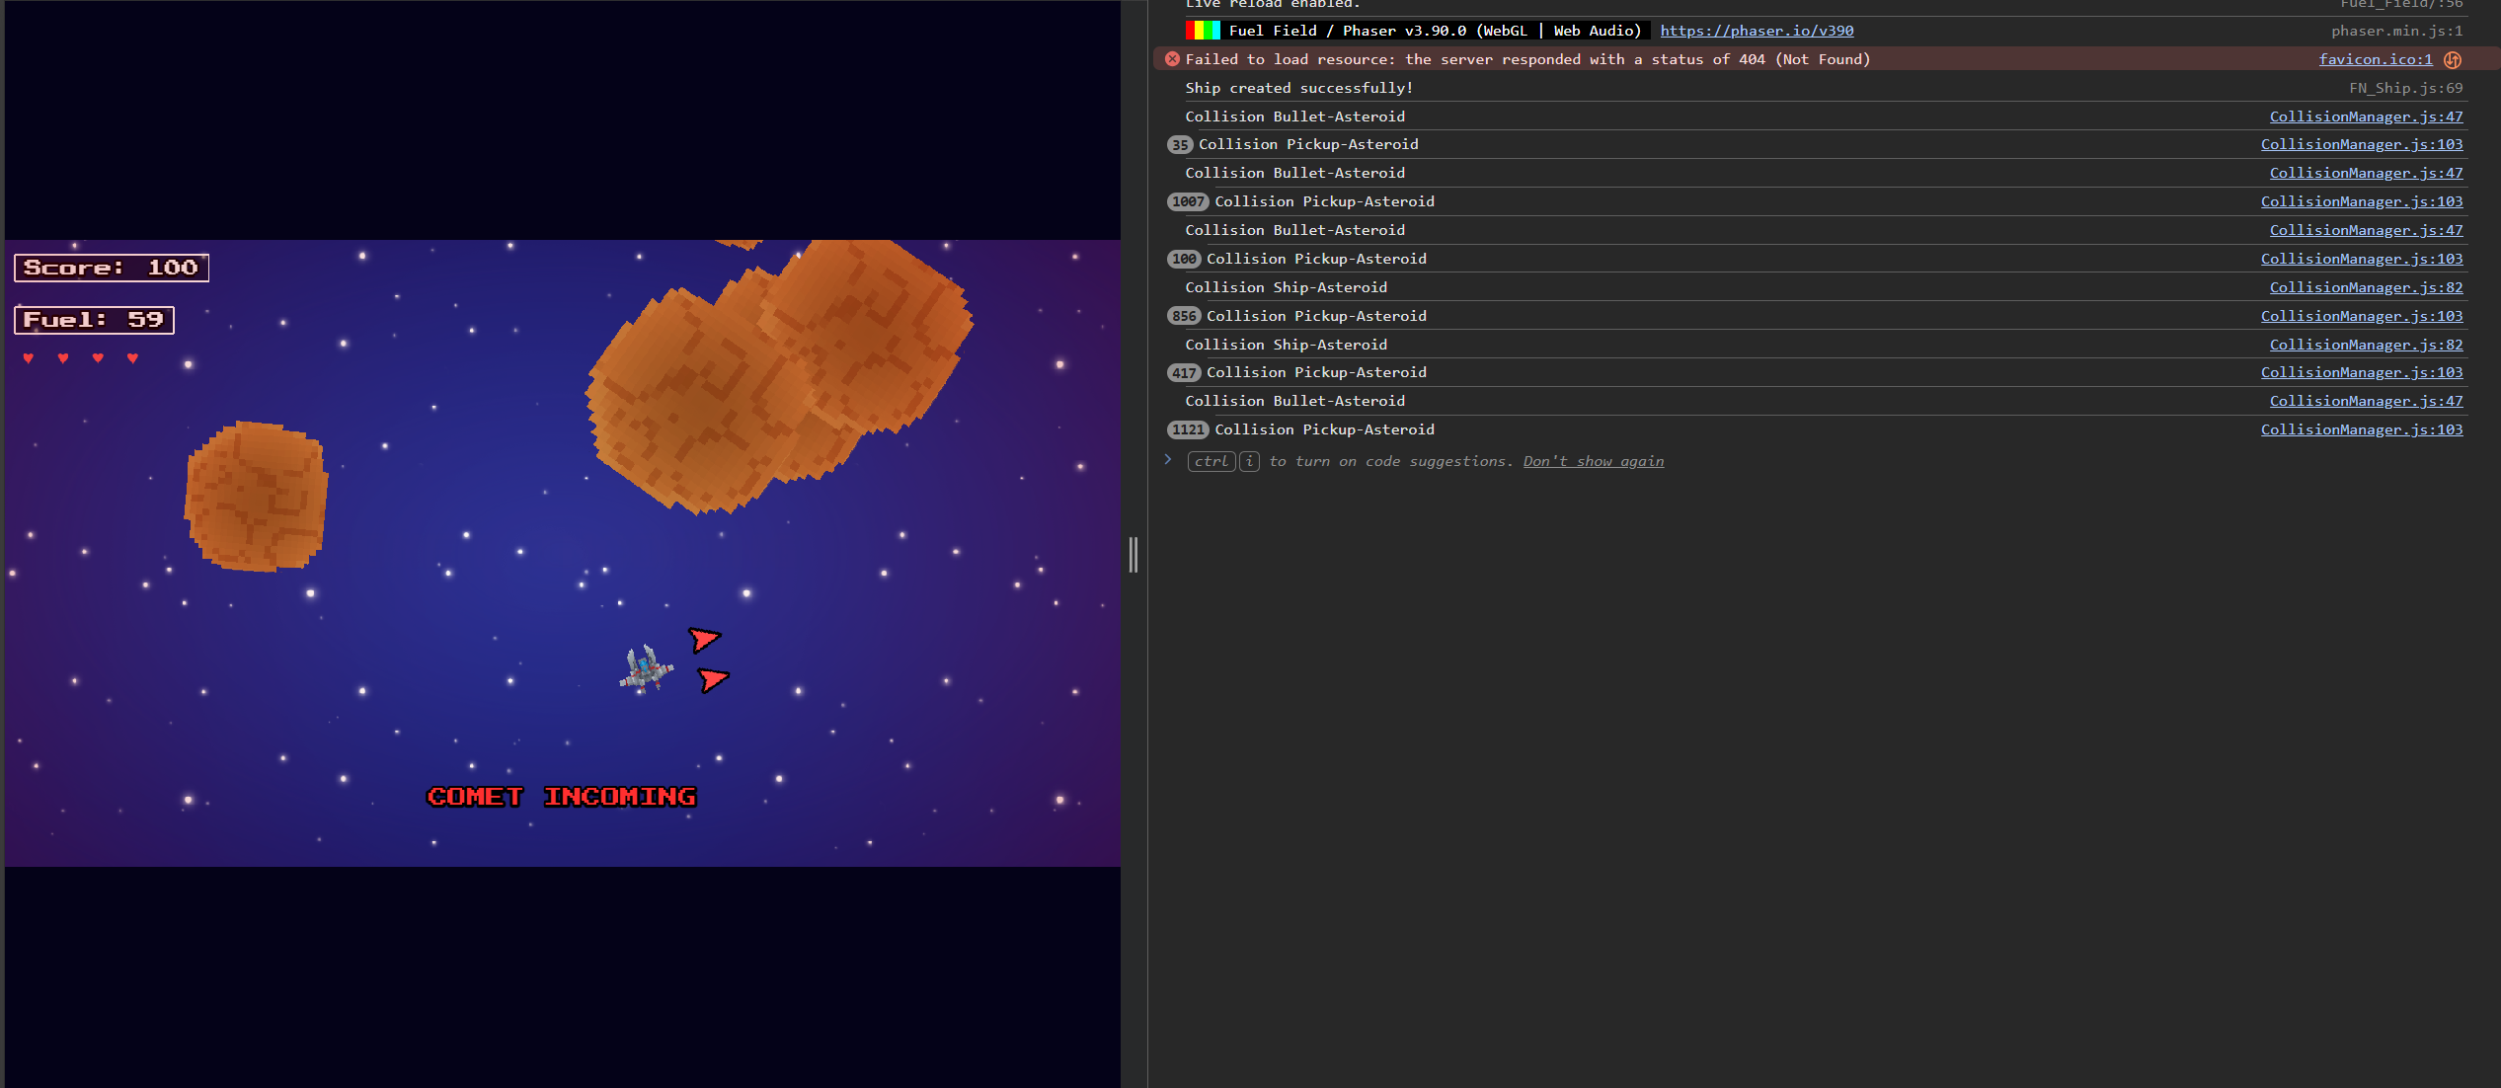
Ship to asteroid collisions use the same distance based approach bust also trigger knockback, stagger and iFrames through the players damage response system. Ship to pickup interactions is checked in a similar manner and routed to the Pickup Manager to apply the correct effect.
PICKUP AND KNOCKBACK SCREENSHOTS
Centralising this logic keeps the Main Scene streamlined and allows collision rules to evolve without altering unrelated systems. By moving away from Phasers Arcade Physics overlaps and implementing explicit manual checks, the game maintains stable and predictable Collison behaviour throughout all difficulty levels.

Pickup Manager:
The “FN_PickupManager” centralises all logic for creating and applying fuel, shield and speed boost pickups. When a pickup is spawned, it is added to a dedicated group in the Main Scene so it can be tracked consistently, by the collision system. Although Phaser supports assigning Arcade Physics bodies to sprites, pickups intentionally avoid physics bodies to reduce overhead and maintain full control over their behaviours. This aligns with Phasers documentation, which notes that Arcade Physics introduces continuous simulation that may be unnecessary for simple collectable entities (Phaser, 2024).
https://docs.phaser.io/api-documentation/class/physics-arcade-arcadephysics
SCREENSHOT OF FUEL PICKUP DROPPING AFTER ASTEROID DESTRUCTION
Each pickup type provides a distinct effect:
- Fuel Pickups: restore a small, randomised amount of fuel.
- Shields: grant temporary invulnerability and apply a blue tint whilst active.
- Speed Boosts: briefly increase thrust and turn speed, restoring original values when the effect finishes.
Floating text, audio cues and colour tints ensure feedback remains consistent without requiring separate implementations in the player or collision system.
FLAOATING TEXT FEEDBACK FROM PICKUP COLLECTION SCREENSHOT
By routing all pickup interactions through a single manager, new pickups types can be added easily, and visual feedback stays uniform across the game. The Pickup Manager therefore plays a key role in reinforcing pacing, survivability and reward timing throughout the run.

Comet Warning Manager and Idle Timer:
The comet warning system was added to discourage prolonged idle behaviour and maintain overall pacing. It is handled by the dedicated “FN_CometWarningManager”, which monitors the players movement each frame. If the ship remains below a minimal velocity threshold for too long, an idle timer triggers a comet event. This prevents passive play and reinforces movement as a core skill.
COMET WARNING SCREENSHOT
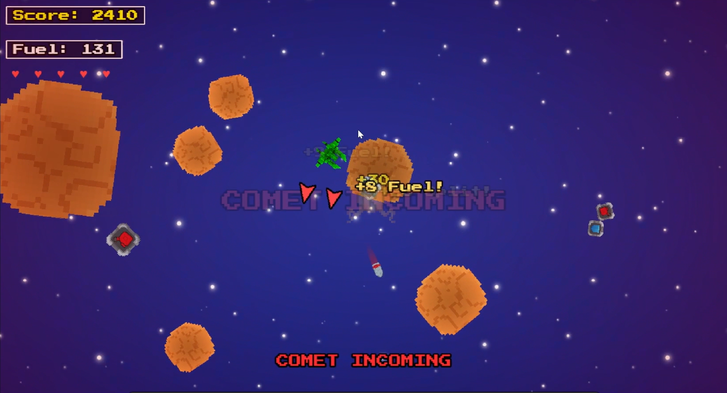
When activated, the system displays directional arrow indicators that point toward the comets position, giving the player clear information about where the incoming threat is approaching from. These indicated update as both the comet and ship move, ensuring that the warning remains readable in real time. A looping alert sound and brief vignette pulse reinforce the sense of danger.
DIRECTIONAL ARROWS + VIGNETTE SCREENSHOT
The comet system integrates smoothly with existing gameplay, activating only when necessary and remaining unobtrusive during normal movement. Overall, it provides but effective method of preventing low engagement play while maintaining the tension during those longer runs.

Helper Utilities:
Fuel Field uses several small utility classes that support the main gameplay systems and help to keep the project modular. These utilities handle behaviours that do not belong to any single manager, which allows the Main Scene to remain focused and reducing any duplicate code.
The “WrapHelper” class controls all the screen wrapping logic for the ship, asteroids and projectiles. Any object that moves beyond the screen boundaries is repositioned to the opposite side. Keeping this behaviour in a separate helper keeps consistent wrapping across all moving objects.
WRAPPING BEHAVIOUR SCREENSHOT
The “UIHelpers” provide, small, shared UI functions such as vignette fading, parallax background movement and temporary visual cues. These effects are triggered by other systems like the low health and idle warnings, they allow the UI to stay readable without each manager maintaining its own code animation.
VIGNETTE AND PARALLAX SCREENSHOT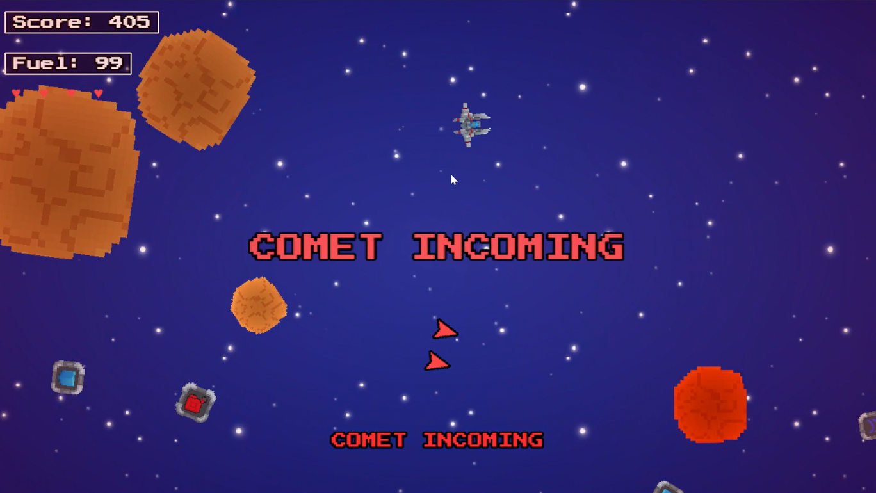
The “ExplosionManager” handles spawning explosion effects when asteroids or the player is destroyed. It standardises animation settings and keeps all explosion behaviour consistent.
EXPLOSION EFFECT SCREENSHOT
Floating text feedback is created using a simple “FloatingText” utility class. This helper spawns short lived text objects that rise and fade out to show score gains, fuel amounts or pickup effects. This keeps all text behaviour consistent and avoids clutter.
FLOATING TEXT SCREENSHOT
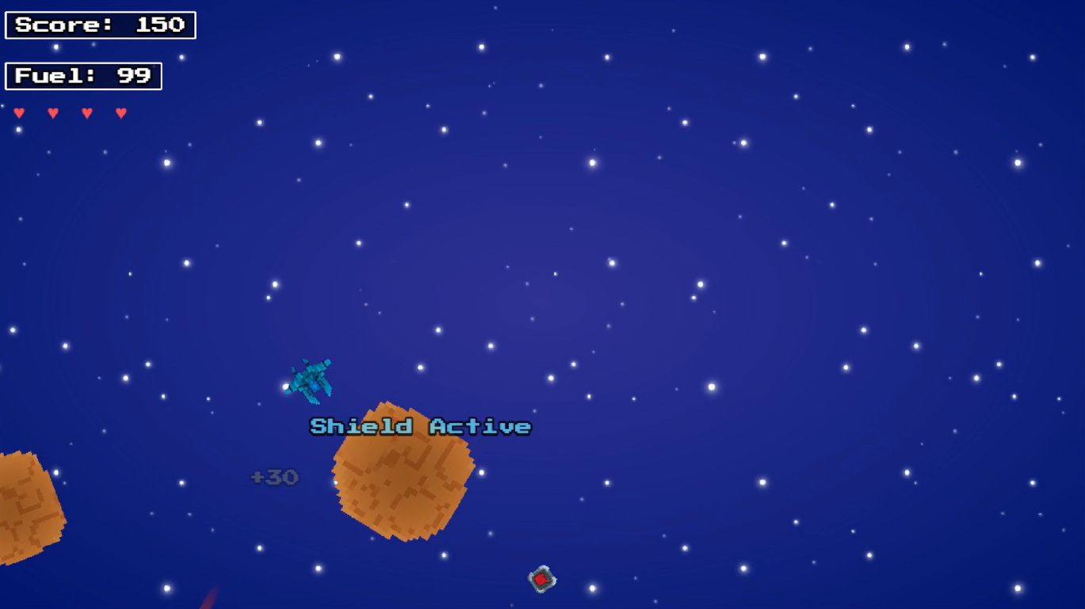
Together, these helper utilities keep repeated tasks centralised and allow core system such as the Player, Asteroids and Managers to focus only on their own responsibilities.

Upgrade System:
The upgrade system introduces small, incremental improvements that help the player extend their run variety without shifting the game away from its core arcade structure. It is managed by a dedicated “FN_UpgradeManager” class, which monitors the players score and triggers upgrade events whenever specific score thresholds are reached. These thresholds scale over time which ensures upgrades appear at a controlled interval rather than overwhelming the gameplay flow. This was introduced as earlier iterations of the systems introduced problems when reaching later stages of gameplay, it became increasingly harder to play, because the values for the upgrade managers events were static and would not scale.
UPGRADE MENU TRIGGERING AFTER SCORE THRESHOLD SCREENSHOT
When an upgrade event is activated, gameplay is temporarily paused. Asteroids stop moving, new spawns are stopped, and the player cannot take any incoming damage. This pause helps to communicate to the player they have a clear, uninterrupted moment during gameplay, to drive away some tension. The player must then make their selection, which the menu presents three upgrades chosen randomly from the categories, including weapon improvements, mobility boosts, fuel extensions and survivability bonuses.
UPGRADE MENU OPEN SCREENSHOT
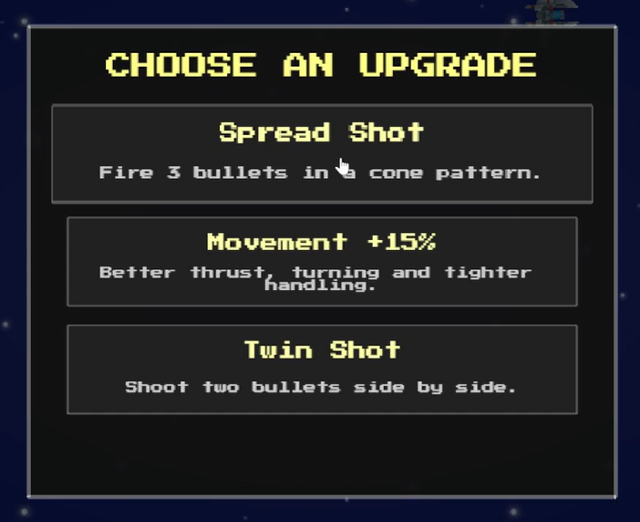
Weapon upgrades modify the behaviour of the “FN_Gun” class, they enable patterns such as the Twin Shot, Spread Shot or Auto Fire. These patterns are generated through small adjustments to projectile angles or spawn offsets, allowing for more complex behaviours without changing the base projectile system.
SPREAD SHOT OR TWIN SHOT ACTIVE SCREEN SHOT
Resource based upgrade enhance the maximum fuel or regeneration, prolonging the players ability to rely on boosting at higher difficulty levels. Mobility upgrades momentarily increase thrust or turn speed, while defensive upgrades may add temporary shielding or improve heart regeneration cooldowns. Each upgrade stacks with previous choices, allowing the player to gradually shape their run toward specific strengths.
FUEL OR HEALTH STAT UPGRADE SCREENSHOT
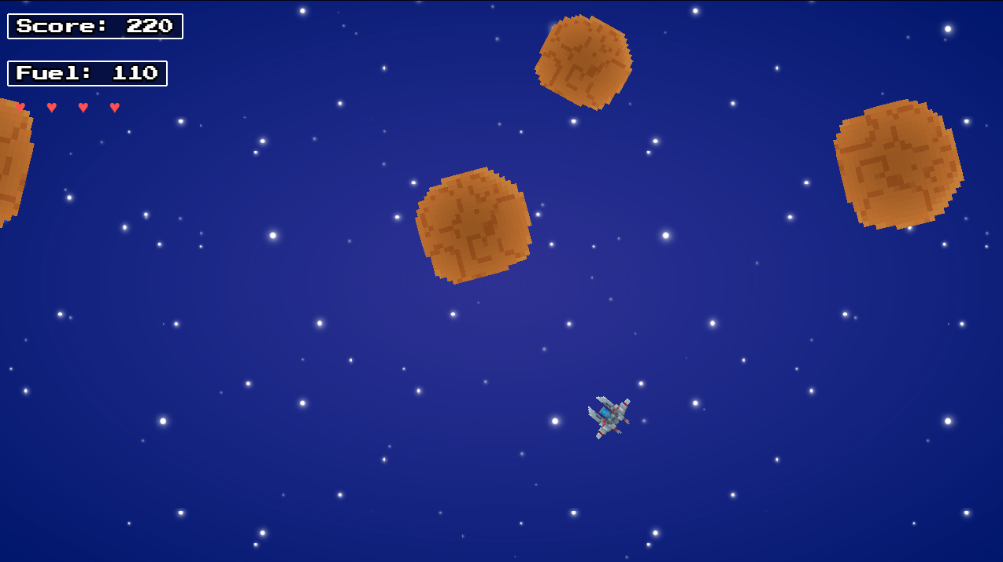
Once the player selects an upgrade, the menu closes and gameplay resumes instantly. The spawner, asteroids and UI animations all return to their normal behaviour. This ensures that the upgrade system fits seamlessly into the pacing and doesn't break the flow of a run.
Overall, the upgrade system adds controlled variety and complements the score loop by rewarding consistent player performance. Its modular design allows new upgrade types to be added very easily, without requiring changes in the Main Scene or player code.

Spawner System:
The asteroid spawner is responsible for generating new threats throughout the run and scaling the difficulty over time. It operates separately from the “FN_Asteroids” class and is created by the Main Scene at the start of gameplay. The spawner tracks an internal timer, when the interval expires, a new asteroid is created a random point along the screen edge.
Asteroids always spawn outside the visible play area and are assigned a direction that leads them toward the centre of the screen. This helps make sure that spawns remain predictable and readable regardless of where the player is positioned on the screen. The spawner also assigns randomised values such as size, rotation and movement speed, giving each asteroid slight variation.
ASTERPODS SPAWNING AT SCREEN EDGE SCREENSHOT
Difficulty increases gradually as the spawner lowers its intervals and raises the minimum speed values over time. This scaling keeps the pressure on the player and ensures that longer sessions don’t become as easily predictable. The spawner checks the global difficulty level each cycle and adjusts its parameters accordingly to maintain the pacing.
DIFFICULTY SCALING OVER TIME SCREEN SHOT (DEBUG)
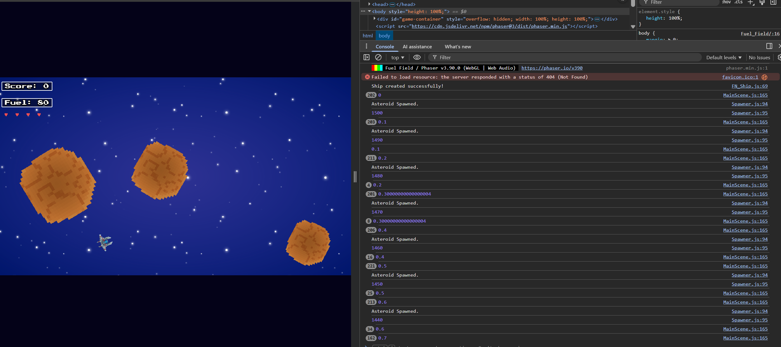
When the upgrade menu is open, the spawner temporarily pauses. This is to prevent unfair scenarios where asteroids could enter the screen whilst the player is upgrading, where they could be potentially hit enough times to die. Once the selection has been made however, the spawner resumes its normal cycles.
UPGRADE MENU PAUSING GAMEPLAY SCREENSHOT
By isolating this behaviour into a dedicated system, the Main Scene became a lot cleaner and now only needs to request new asteroids rather than manage timing, and scaling logic directly. The spawners modular design also makes it straightforward to adjust balance values or introduce additional enemy types in future versions.

Assets:
The visual assets for Fuel Field were created using the Space Shooter Starter Pack made by (Anim86), with edits to pixelation, colour and scale for stylistic consistency. These edits were done to the; Ship, Asteroids, Fuel, Health and background sprites. All assets annotated have a corresponding asset in the Space Shooter Starter Pack.
The game uses sprites and background textures from the Space Shooter Starter Pack (Anim86, n.d) with slight recolouring and scaling adjustment for visual cohesion. The fuel bar and UI text were created directly using Phasers built in graphics and text APIs.
The background music used in the game was also composed by me. The track was originally produced in SoundTrap (circa, 2021), uploaded privately to SoundCloud for storage, and later redownloaded for inclusion in this project. All musical content during gameplay is original and student created.
However, the menu background music uses a third party track sourced from FreeSound.org: https://freesound.org/people/ShnitzelKiller/sounds/87084/?
All sound effects (shooting, boosting, warning chime, pickup sounds, damage effects) were created by me using the SFXR sound generator (https://sfxr.me/ ). no commercial audio libraries or pre made packs were used.

Research:
Before implementing the final design of Fuel Field, a range of arcade and modern action titles were researched to guide decisions around mechanics, visual identity, and feedback systems. The analysis formed the projects three main design pillars: clarity, responsiveness, and tension.
Classic Arcade Influence:
The core movement and shooting system is mostly inspired by Asteroids (Atari, 1979). The game adopts Asteroids intertia based movement controls to keep that sense of drift and weight that a ship would carry in space.
Visually, Fuel Field does not follow in Asteroids vector art based aesthetic. Instead, it follows a pixel art artstyle that draw inspiration from titles like Galaga (1981), which showed the effectiveness of pixel art and instantly readable enemy sprites. This informed the decision to keep assets simple, stylised, and high contrast.
Modern Pixel Shooter Influence:
Other influences from more modern titles such as Nova Drift (Chimeric, 2019), helped shape the games visual tones with deep blues, subtle star fields and saturated orange and reds for feedback and danger states. Nova Drift also demonstrated how minimalist and uncluttered UI can help communicate more complex game states clearly, which helped the design of Fuel Fields heart based health system and fuel gauge.
The tension loop of Fuel Field, where the survival relies purely on constant movement, fuel pickups and avoiding collisions. Is partly inspired by FTL: Faster than Light (Subset games, 2012) and traditional arcade shmups. These games emphasise resource management under pressure, which directly influenced the decision to tie the weapon fire rates and boost behaviour to the players fuel percentage to create tension.
Survivability and Feedback Influence:
The addition of a red vignette, heartbeat style warnings, and synthesised danger audio draws inspiration from more recent titles such as Vampire Survivors (Poncle, 2022), and shooters like DOOM. These games show how audiovisual exaggeration can make danger states unmissable without cluttering the UI.
Fuel Field uses similar principles:
- A pulsating red vignette signals death is near
- A short synth tone emphasises the damage feedback
- Hearts dim and regenerate slowly to maintain long term tension
These systems were all informed by modern “survivor” and “boom shooter” feedback patterns which prioritise readability, which for the aesthetic Fuel Field was trying to achieve, this was perfect.
Replayability and Upgrade Loop Influence:
During development it became clear that although the original core loop was effective (move, avoid, shoot, collect fuel). It became predictable in longer play sessions. To address the issue, a minimal upgrade layer was introduced. This decision was primarily informed by modern “survivor-like” titles such as Vampire Survivors and most recently, Megabonk. Both of which demonstrate how small, incremental upgrades can dramatically increase replayability without overwhelming the core simplicity of an arcade design.
Academic research into rogue like progression systems support this design approach. For example, Cook and Smith (2021) highlight how lightweight procedural upgrades can create sustained engagement by offering variation between each run while keeping player mastery. This aligns with the goal of Fuel Field, introducing variety without expanding the project scope beyond its intended arcade foundation.
Influenced by these patterns, Fuel Field incorporates small stat based upgrades (weapon adjustments, fuel bonuses) designed not to transform gameplay into a full rogue like, but to provide subtle variation and replay value that aligns with the simplicity of the original concept.
Summary of Research:
Through this research, Fuel Field Aims to blend the clarity of early arcade shooters with the stylistic polish and audiovisual quality of modern indie titles. The result is a reinterpretation of the classic space shooter formula, one that preserves the simplicity while incorporating modern game feel, tension, and feedback systems.

Implementation Evaluation:
The implementation of Fuel Field successfully delivers a modern take on an arcade shooter while maintaining clarity, responsiveness and modularity as core development priorities. Throughout the project, the decision to structure the game around focused managers and helper utilities proved highly effective. Each system like; spawning, collisions, UI feedback, upgrades and movement could be iterated on independently, reducing complexity and enabling consistent code refinement across the development cycle of the project.
One of the most impactful technical decisions was the move away from Phasers built in Arcade Physics overlaps in favour of fully manual collision checks. Phasers documentation notes that its physics bodies do not use continuous collision detection, which caused early tunnelling issues when testing high projectile speeds. Replacing these with explicit radial distance checks proved more predictable, stable and resolved several misregistration bugs during playtesting. Although this approach required more work initially, it gave far more control and ensured that the interaction between bullets asteroids and the player behaved at all difficulty levels.
The feedback systems implemented throughout the project also contributed strongly to the overall player experience. Elements such as floating text, colour coded tints, screen vignette pulses and warning sounds made sure the player always received immediate readable feedback about game state changes. These systems improved the feel of movement, damage and reward, especially during a high pressure scenario, created by faster asteroids or low fuel moments. The comet warning system further improved this by preventing passive play and emphasising the core games loop of continuous movement.
The upgrade system introduced a meaningful variety without shifting the scope away from its arcade foundation. Earlier iterations of the game suffered from predictable pacing, particularly in longer sessions. Implementing a score based upgrade system solved this problem by tying progression directly to performance, which created natural difficulty and variety. However, the current upgrade pool remains relatively small, and further expansion could improve replay value in future versions. Likewise, while the fuel and health systems integrate smoothly with the upgrade architecture, additional depth in the future could create more strategic decisions.
There were also some limitations. The manual collision approach, while effective, may not scale easily if more enemy types or denser patterns are added in the future. Some visual elements such as explosions or asteroids sprite could be further polished to improve their alignment with the aesthetic. Additionally, although the UI is clear and functional, more advanced animation could enhance the presentation.
Overall, the final implementation demonstrates a well structured and maintainable codebase that meets the original design goals. Fuel Field blends classical arcade influences with modern feedback techniques and successfully balances accessibility, tension clarity. The project provides a strong foundation for future expansion and reflects a solid understanding of Phaser, modular architecture and iterative game development.

Appendix:

Debugging:

Fuel:
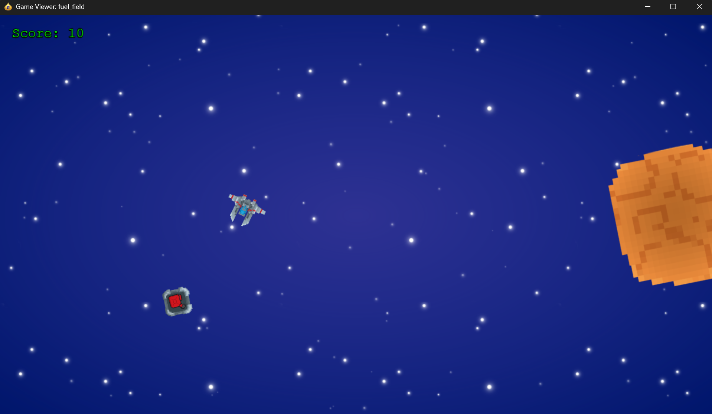
Screenshot of testing whether the fuel items drop correctly. The Player is the Ship, the Fuel is the grey box with the red fuel icon in the centre, and the asteroids are the yellowish and orange circles.
Testing of the fuel UI text game object. which tracks the current fuel of the players ship and updates dynamically depending on events like (AsteroidHit(), or FuelPickup()) for example.
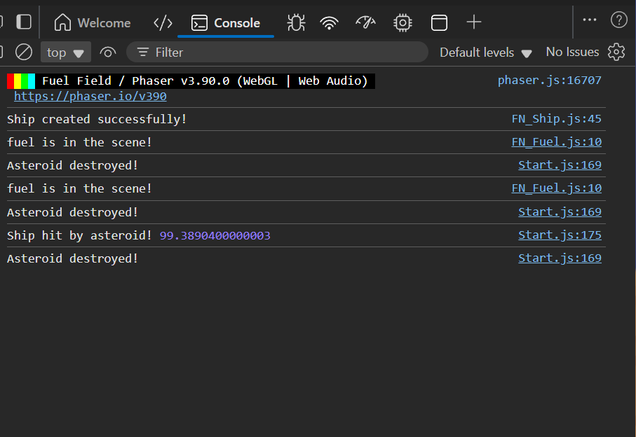
This screenshot shows a successful test of the Fuel Manager and asteroid collision system, When the players projectile hits an asteroid, a fuel pickup (grey box with red core) spawns in the scene. The console log confirms that the asteroid was destroyed, and a new fuel instance was made. The player (ship) can collect the fuel increasing the fuel which is displayed in the UI.

Upgrades:
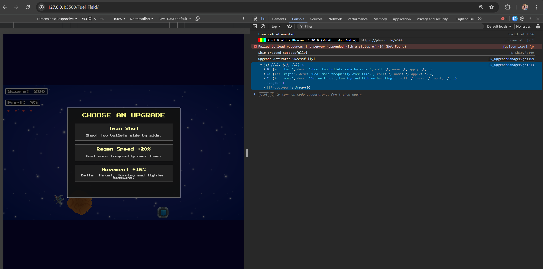
Debugging the upgrade system. This screenshot shows the upgrade menu triggering at the score threshold and logs verifying that three upgrade options were successfully rolled and activated.

Collision:
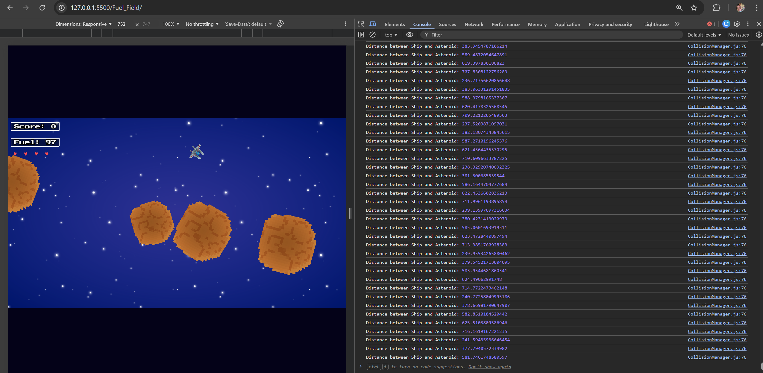
This console output shows the manual radial distance checks between the player ship and nearby asteroids. These tests were used to verify the accuracy and stability of the custom collision detection system implemented in place of Phasers.

Spawner:
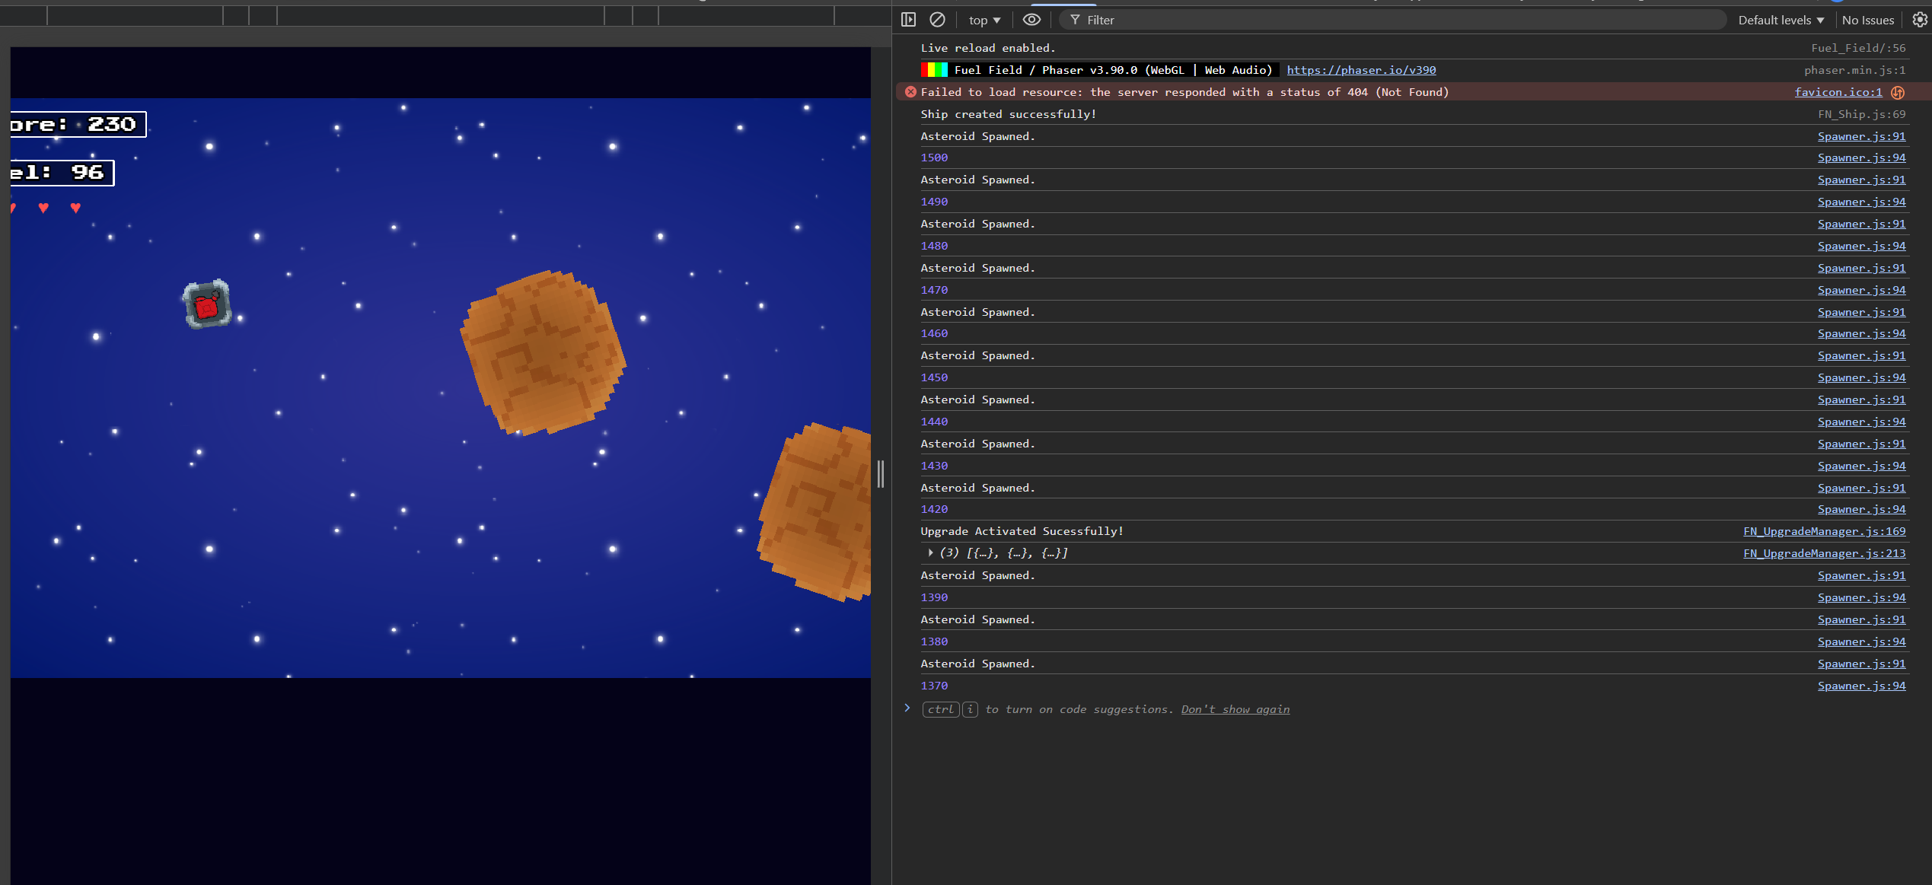
This console output demonstrates the spawner system generating asteroids at progressively reduced rates, confirming that the intended difficulty scaling and timing behaviour during extended play sessions.

Code Snippets:

FN_Ship:
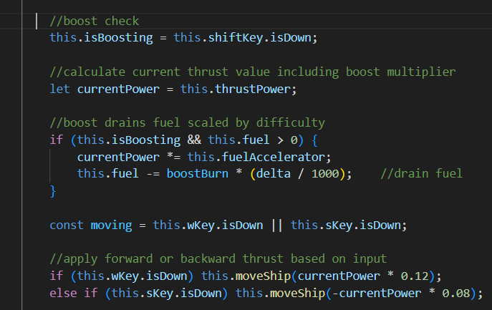Player Movement and boost logic.
This snippet applies thrust, calculates the boosted movement and drains fuel while the boost key is held.
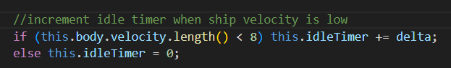Idle Timer behaviour
This logic tracks low movement periods and feed s this into the comet warning manager.
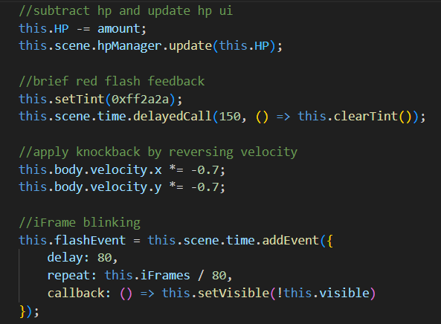
Damage response logic.
This snippet shows HP reduction, knockback, flashing feedback and temporary invulnerability frames after taking damage.

FN_Gun:
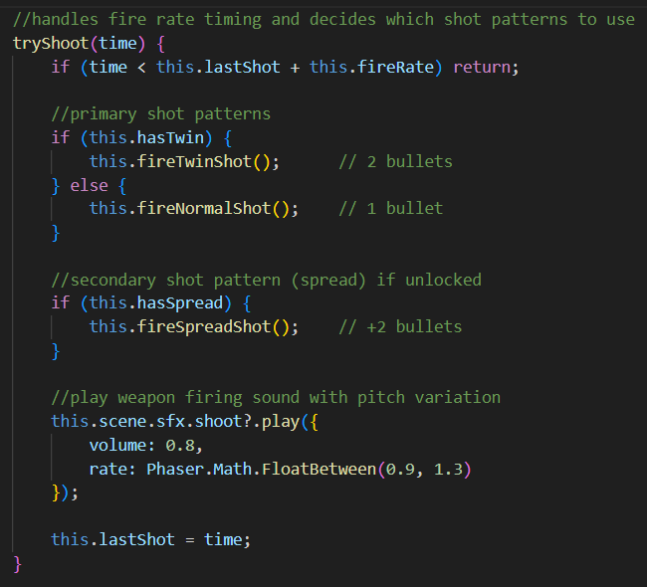Firing Logic and upgrade chosen shot patterns.
This function checks cooldown timing and activated different firing patterns depending on unlocked upgrades such as Twin Shot or Spread Shot.
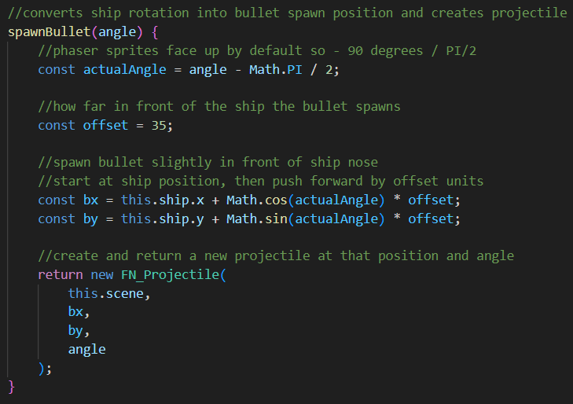Projectile spawn calculation.
This snippet converts the ships rotation into a forward facing bullet position and angle. This helps projectiles originate from the ships nose.

Gameplay Recording:
Around a 2 minute gameplay recording demonstrating the movement, UI feedback and asteroid behaviour, spawning and comet warnings and the upgrade system is available at:
https://youtu.be/hqb0D9qytk8

Play the Game:
https://fn170.brighton.domains/
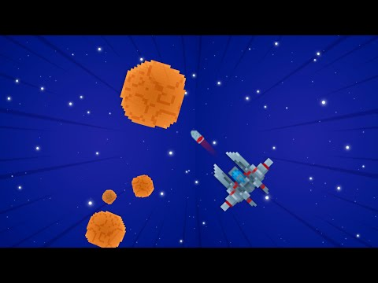

References:
Atari (1979) Asteroids [Video Game]. Atari, Inc.
Namco (1981) Galaga [Video Game]. Namco Ltd.
Chimeric (2019) Nova Drift [Video Game]. Chimeric.
Cook, J. & Smith, R. (2021) Procedural Progression Systems in Roguelike Game Design. Journal of Interactive Media, 14 (2)pp. 44-59.
Id Software (1993) DOOM. [Video Game] id Software.
Subset Games (2012) Faster than Light. [Video Game]
Megabonk (2024) Megabonk. [Video Game] Poncle-like Publishing. Available at: https://store.steampowered.com/app/3405340/Megabonk/
(Accessed 28th November 2025)
Poncle (2022) Vampire Survivors. [Video Game] Poncle.
Phaser (n.d) Phaser 3 API Documentation. Available at: https://newdocs.phaser.io (Accessed: 8th October 2025)
Anim86 (n.d) Space Shooter Starter Pack. Itch.io. Available at: https://anim86.itch.io/space-shoter-starter-pack (Accessed: 8th October 2025)
ShnitzelKiller (2009) Mystic Ambient Loop [music]. FreeSound. Available at: https://freesound.org/people/ShnitzelKiller/sounds/87084/? Accessed (1st December 2025)
SFXR generator: DrPetter (n.d.) SXFR Online Sound Generator. Available at: https://sfxr.me/ Accessed (1st December 2025)

